# Interior fraser river coho (*Oncorhynchus kisutch*) stock assessment for 2022

|  |
| --- |
| Context:  Stock and Assessment Overview: Interior Fraser River Coho Salmo  n.  This Fisheries Science Response Report was written to streamline information and advice for the conservation and management of the Interior Fraser River Coho Salmon (IFC) Stock Management Unit (SMU). Given the technical nature of the document, a glossary is provided in Appendix 1.  This Science Response Report is from April 29, 2024 Salmon Week and the follow-up meeting occurred on November 15, 2024. *The specific objectives of this report are to:*  1. *Describe the stock status and trends, taking into account assumptions regarding stock structure and distribution.* 2. *Describe the ecosystem and climate change considerations affecting the stock.* 3. *Evaluate/estimate candidate reference points (e.g., Upper Stock Reference (USR)).* 4. *Evaluate/estimate the impact of candidate harvest and/or management options on the stock.* 5. *Evaluate/estimate if the Stock Management Unit (SMU) is below the Limit Reference Point (LRP).* 6. *If the stock is below the LRP, describe what is known and the existing data gaps in our understanding of why the stock is below its LRP.* 7. *Specific objectives: update the USR and Removal Rate (RR), and update the exploitation rate (ER) vs. survival plots from Arbeider et al. 2020.*   Additional publications from this meeting will be posted on the [*Fisheries and Oceans Canada (DFO) Science Advisory Schedule*](http://www.isdm-gdsi.gc.ca/csas-sccs/applications/events-evenements/index-eng.asp) as they become available. |

## SCIENCE ADVICE

### Status

The Interior Fraser River Coho (IFC) Stock Management Unit (SMU) is above its Conservation Unit (CU) status-based Limit Reference Point (LRP) and therefore not in the critical zone under the PA framework:

* In 2024, DFO’s Salmon Scanner assigned ‘Green’ status to four of the IFC CUs (Lower Thompson, South Thompson, North Thompson, and Middle Fraser) and ‘Amber’ status to one CU (Fraser Canyon) (C. A. Holt et al., 2023; K. Holt et al., 2023; Table 1; see Figure 1 for a map of the CUs).
* In 2016, the Committee on the Status of Endangered Wildlife in Canada (COSEWIC) assessed IFC as Threatened (COSEWIC, 2017)
* In 2014 during the last Integrated Status Assessment of IFC, three of the five CUs were assigned a status of ‘Amber’ (Middle Fraser, Fraser Canyon, and South Thompson) and two CUs were assigned a status of ‘Amber/Green’ (Lower Thompson and North Thompson; DFO, 2015)
* IFC aggregate spawner abundance crashed in the early 1990s, experiencing declines in excess of 60%
* Since 2020, all CUs within the IFC SMU have experienced increases in abundance

### Ecosystem and Climate Change Considerations

* IFC are threatened by diverse anthropogenic and natural threats, all of which will be exacerbated by anthropogenic driven climate change (Bradford and Irvine 2000; Arbeider et al. 2020).
* A regime shift in smolt-to-adult survival (SAS) from a period of high survival (return year 1987-1994) to low survival (return year 1994-current) is attributed to changing ocean conditions (Decker et al. 2013).

### Stock Advice

* The maximum sustainable harvest rate for the SMU is 0.36 (based on the Lower Thompson CU, which has the lowest median UMSY; Tables 2 & 3)
* When aggregate spawner abundance exceeds 33,500 and 65,300 fish (Fisheries Reference Points-Lower (FRP-L)), the probability of the IFC SMU being above the CU-based LRP (i.e., no CUs below their lower benchmarks (CU-specific Sgen)), is 66% and 90%, respectively (K. Holt et al., 2023;Table 2)
* In the last 5 years of escapement data (2017-2022), aggregate spawner abundance has exceeded 33,500 fish 4 times, and 65,300 fish 3 times (Figure 2)

## BASIS FOR ASSESSMENT

### Assessment Details

#### Year Assessment Approach was Approved

DFO methods to assess the status of Pacific Salmon CUs were identified and approved in 2009 and the Pacific Salmon SMU LRP methods were approved in 2022/2023 (Holt 2009; DFO 2022; Holt et al. 2023b, 2023a)



#### Assessment Type

Full Assessment

#### Most Recent Assessment Date

1. Last assessment: Interior Fraser Coho Salmon Recovery Potential Assessment (Arbeider et al. 2020).
2. Last Full Assessment: 2014 (DFO 2015a). No Full Assessment has been made under the *Precautionary Approach* (PA) Framework.
3. Last Interim Year Update: Not Applicable.

#### Assessment Approach

1. Broad category: Stock assessment model.
2. Specific category: Pacific Salmon Status Scanner Rapid Assessment Analysis (DFO, 2024; Grant & Pestal, 2012), Spawner Recruit Analysis (Ricker Model; Bailey, 2024); Simulation Analysis (Bailey 2024).

This IFC assessment used previously established, peer-reviewed methods to identify stock status, calculate reference points, and describe spawner trends. Briefly, the Pacific Salmon Status Scanner is a tool that approximates Wild Salmon Policy Integrated Status Assessment outcomes using an algorithm trained on historical status assessments and standardized data on CU abundances and trends (DFO, 2024; Grant & Pestal, 2012). For spawner recruit analysis, the Ricker spawner-recruitment curves fit to brood-year estimates of spawners and recruits described in K. Holt et al. (2023) were reproduced using the Bayesian statistical programming languages R (R Core Team and contributors worldwide 2017) and Stan (Carpenter et al. 2017). Each CU was modeled twice with the following linearized stock-recruit function:

where R = recruits, S = spawner abundance, p = proportion of recruits at age, β = density dependence coefficient, α = productivity coefficient, γ = smolt-to-adult survival (SAS) coefficient, SAS = SAS of recruits at age, and σ = standard deviation of variation in recruitment. On the first round of modeling, stock recruit relationships were fit to each CU without a cap on Srep, and on the second round, relationships were fit with CU-specific caps on Srep (Holt et al. 2023b; Bailey 2024). Final stock recruitment parameter means, medians and confidence intervals were calculated from the combined posteriors of both model sets (see Bailey, 2024 and K. Holt et al., 2023 for details). Finally, using the fitted parameters from the stock-recruit analysis, IFC SMU abundance was simulated into the future using code adapted from Arbeider et al. (2020) to estimate the frequency with which IFC SMU abundance will exceed FRP-Ls and achieve positive population growth (see Bailey, 2024 for simulation code) under differing SAS and exploitation rates (ERs; Figures 4-6).

### Stock Structure Assumption

Stock overview information: (Arbeider et al. 2020)

The IFC SMU includes all Coho Salmon that spawn in the Fraser River Watershed upstream of Hells Gate in British Columbia and consists of five CUs: Fraser Canyon, Middle Fraser, Lower Thompson, South Thompson, and North Thompson (Table 1; Figure 1). The CUs are further delineated into 11 subpopulations. The Fraser Canyon has one, the Middle Fraser has two, the Lower Thompson has two, the South Thompson has three, and the North Thompson has three subpopulations (Interior Fraser Coho Recovery Team 2006). IFC are genetically distinct from Lower Fraser Coho, and the current assignment of spawning populations to CUs generally agrees with the most recent genetic evidence (Xuereb et al. 2022). On average 88% of IFC have a three year life-cycle and 12% have a four year life-cycle, with both spending one winter in saltwater. Rarely do IFC return at ages older than four or less than three years of age.

*Table 1. List of Conservation Units (CUs) within the Interior Fraser Coho Stock Management Unit with corresponding Designatable Units (DUs), WSP Integrated Statuses, COSEWIC status, and WSP Rapid Statuses.*

|  |  |  |  |  |  |  |
| --- | --- | --- | --- | --- | --- | --- |
| **CU name** | **CTC indicator** | **CU** | **DU** | **WSP Integrated Status (2015)** | **COSEWIC (2016)** | **WSP Rapid Status (2024)** |
| Fraser Canyon | none | CO-5 | Interior Fraser | Amber | Threatened | Amber, medium confidence |
| Middle Fraser | none | CO-45 | Interior Fraser | Amber | Threatened | Green, high confidence |
| Lower Thompson | Coldwater River | CO-7 | Interior Fraser | Amber/green | Threatened | Green, high confidence |
| North Thompson | none | CO-9 | Interior Fraser | Amber/green | Threatened | Green, high confidence |
| South Thompson | Salmon, Eagle Rivers | CO-8 | Interior Fraser | Amber | Threatened | Green, high confidence |

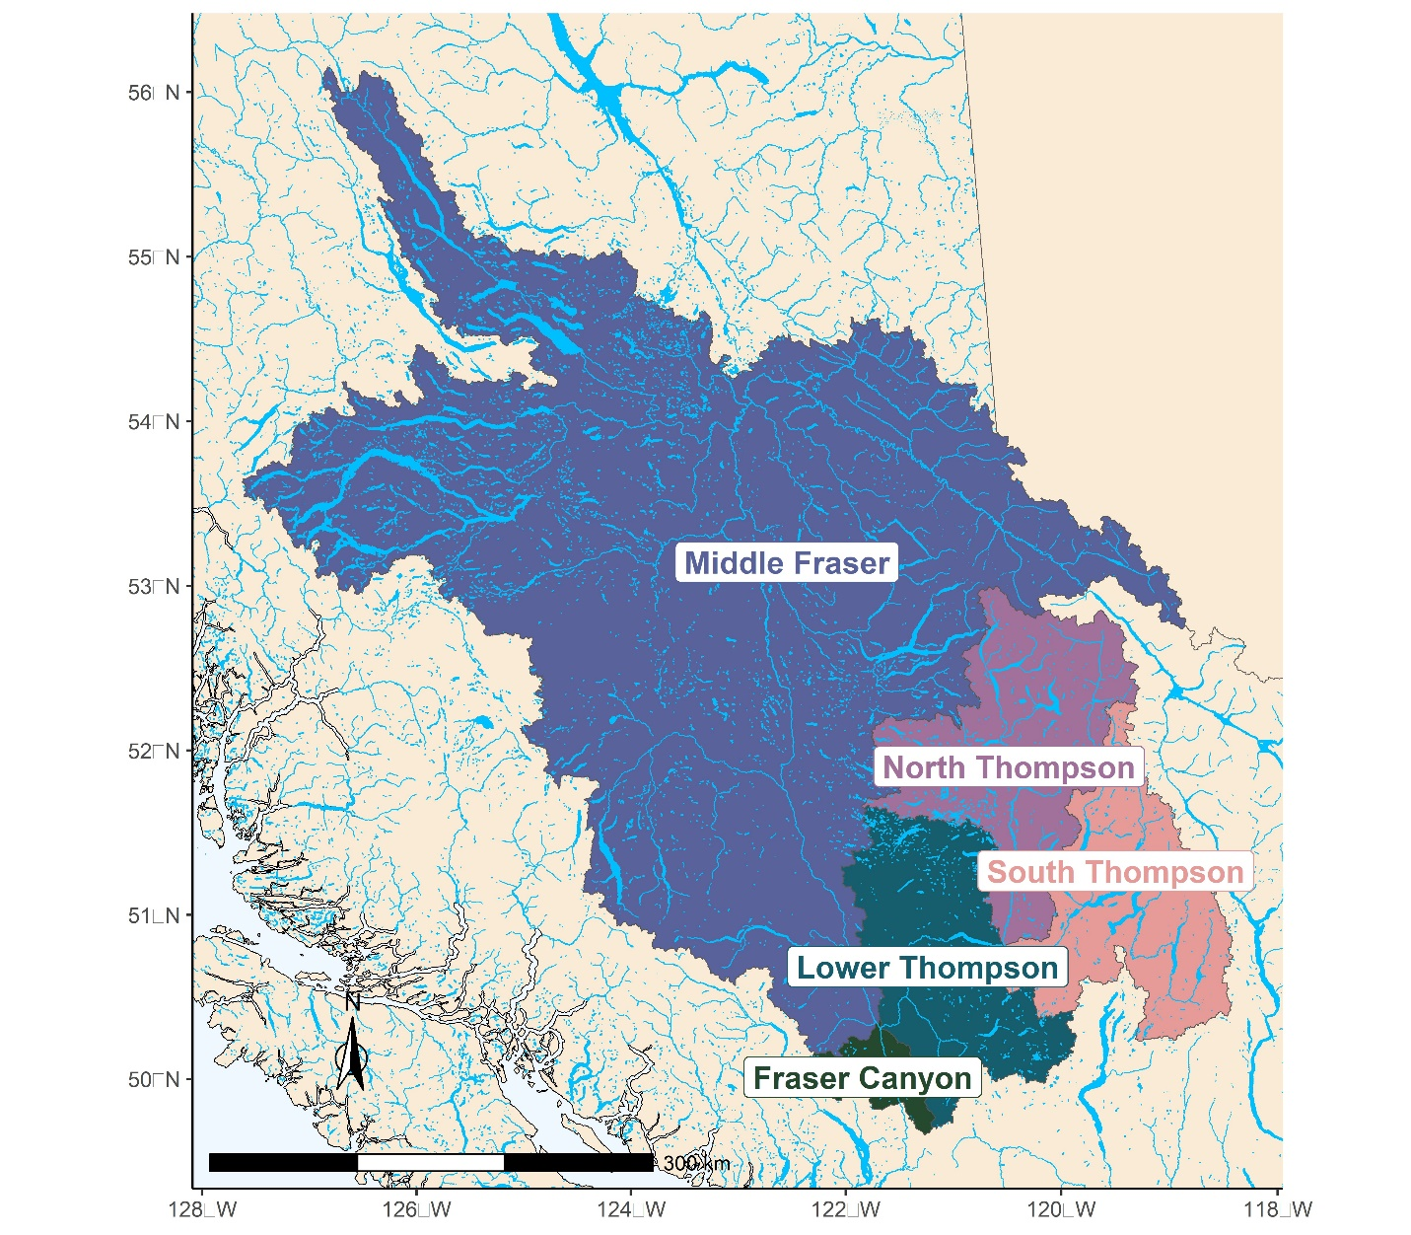

Figure **1.** Delineation of Interior Fraser Coho conservation units (CUs). Interior Fraser Coho spawn in areas upstream of Hell’s Gate and are widely distributed throughout the watershed. Conservation units include Fraser Canyon, Middle Fraser, Lower Thompson, North Thompson, and South Thompson. There are 1-3 subpopulations within each CU for a total of 11: The South Thompson CU includes the Adams River, Shuswap Lake/Tributaries, and Middle/Lower Shuswap subpopulations. The North Thompson CU includes the Lower North Thompson, Middle North Thompson, and Upper North Thompson subpopulations. The Lower Thompson CU includes the Lower Thompson and Nicola subpopulations. The Fraser Canyon CU is only 1 subpopulation within Interior Fraser Coho, which is above Hells Gate. The Middle Fraser CU includes the Lower Middle Fraser and Upper Middle Fraser subpopulations.



### Reference Points

A CU status-based LRP has been defined for IFC based on the recommendations from (Holt et al. 2023b). The CU status-based LRP was recommended to reconcile the scale mismatch between the major stocks (SMUs) referenced in the *Fish Stock Provisions* and the Wild Salmon Policy (DFO 2015a) recommendation to manage populations at the CU scale.

To provide information relevant to the scale of fisheries management (i.e., escapement targets at the SMU scale), aggregate SMU FRP-Ls (Table 2) representing aggregate abundances with 66% and 90% probabilities of all CUs being above their lower benchmarks (Sgen, Table 3) were adopted from K. Holt et al. (2023). Briefly, these targets are based on logistic regression analysis where success is defined as all CUs escaping spawner abundances greater than or equal to their lower benchmarks (CU-specific Sgen; see K. Holt et al., 2023 for details).

CU-specific Removal Reference points (RR) and Upper Benchmarks (80% of SMSY) are described in Table 2 and provided in Table 3.

**Table 2.** Interior Fraser River Coho reference points.

|  |  |  |  |
| --- | --- | --- | --- |
| Reference Point | **Value** | **Description** | **Reference** |
| CU status-based Limit Reference Point (LRP) | 100% of CUs within an SMU have WSP status estimates above red. | CU status-based LRPs use the proportion of CUs within an SMU that are above the WSP ‘Red’ zone. (Appendix 2) | DFO, 2024; C. A. Holt et al., 2023; K. Holt et al., 2023 |
| Fisheries Reference Point-Low (FRP-L) | Aggregate spawner abundance of 33,500 or 65,300 | Aggregate spawner abundances at which the probability of all CUs exceeding their lower benchmarks (Sgen) is 66% or 90%, respectively | Table 6 in K. Holt et al., 2023 |
| Upper Stock Reference (USR) | 80% SMSY (See Table 3) | Candidate USR; 80% of CU natural spawner abundance (S) at Maximum Sustainable Yield (MSY). | C. A. Holt, 2009 |
| Removal Reference (RR) | UMSY (See Table 3) | Candidate RR; Discrete fishing mortality (U) that will produce Maximum Sustainable Yield (MSY) under equilibrium conditions. Note that this value is the lowest CU-specific Umsy value. | Hawkshaw & Walters, 2015 |
| Target Reference Point (TRP) | 80% SMSY (See Table 3) | Candidate TRP; 80% of CU natural spawner abundance (S) at Maximum Sustainable Yield (MSY). | C. A. Holt, 2009 |

#### Other Stock Reference Points

***Wild Salmon Policy* (WSP) Biological Benchmarks:** Under the WSP, Pacific Salmon CUs are assigned statuses of ‘Green’, ‘Amber’, or ‘Red’, delineated by upper and lower abundance-based benchmarks (DFO 2005; 2015; Holt et al. 2009; Table 3). The values shown below were produced by rebuilding the stock-recruit analysis from K. Holt et al. (2023) in R and Stan (Bailey 2024).

**Table 3.** Interior Fraser Coho conservation unit (CU) specific abundance-based benchmarks and reference points with credible intervals.

|  |  |  |  |  |  |
| --- | --- | --- | --- | --- | --- |
| **CU** | **Benchmark** | **Mean** | **2.5% CI** | **50% CI** | **97.5% CI** |
| Fraser Canyon | Sgen | 355 | 140 | **321** | 767 |
| Fraser Canyon | 80% SMSY | 1140 | 926 | **1117** | 1499 |
| Fraser Canyon | UMSY | 0.62 | 0.41 | **0.63** | 0.78 |
| Lower Thompson | Sgen | 2828 | 1203 | **2496** | 5558 |
| Lower Thompson | 80% SMSY | 3931 | 2374 | **3868** | 5626 |
| Lower Thompson | UMSY | 0.35 | 0.13 | **0.36** | 0.54 |
| Middle Fraser | Sgen | 1753 | 967 | **1633** | 3188 |
| Middle Fraser | 80% SMSY | 2688 | 1917 | **2604** | 3856 |
| Middle Fraser | UMSY | 0.38 | 0.23 | **0.39** | 0.52 |
| North Thompson | Sgen | 2981 | 1526 | **2725** | 5655 |
| North Thompson | 80% SMSY | 5839 | 4367 | **5745** | 7743 |
| North Thompson | UMSY | 0.47 | 0.31 | **0.48** | 0.60 |
| South Thompson | Sgen | 2800 | 1229 | **2568** | 5434 |
| South Thompson | 80% SMSY | 4277 | 2740 | **4282** | 6022 |
| South Thompson | UMSY | 0.39 | 0.19 | **0.39** | 0.56 |



*Pacific Salmon Treaty* (PST) management reference points:Allowable exploitation rate (ER) for Canada and the U.S. are defined by the status of the IFC SMU, as outlined in Chapter 5 of the PST. Under this approach, SMU statuses, described as ‘Low’, ‘Moderate’, and ‘Abundant’, are delineated by management reference points that identify joint minimum SAS and aggregate escapement objectives (Arbeider et al., 2020; Treaty between the Government of Canada and the Government of the United States of America Concerning Pacific Salmon, as Amended through June 2023, 2023; Table 4). The aggregate objectives were historically set through qualitative analysis by the Interior Fraser Coho Recovery Team at 40,000 spawners, and have been since updated by Decker et al. (2014), Korman et al. (2019), and finally Arbeider et al. (2020) at 35,935 spawners. This target provides a 95% probability that all 11 subpopulations of IFC escape at least 1000 spawners based on logistic regression analysis (Arbeider et al. 2020).

**Table 4.** Pacific Salmon Treaty smolt-to-adult survival (SAS) and spawner abundance (escapement) reference points delineating Interior Fraser River Coho stock management unit (SMU) statuses of ‘Low’, ‘Moderate’, and ‘Abundant’.

|  |  |  |  |
| --- | --- | --- | --- |
| SMU Characteristic | Low status | Moderate status | Abundant status |
| SAS | SAS ≤ 0.03 | Three consecutive years 0.03 < SAS ≤ 0.06 | Three consecutive years SAS > 0.06 |
| Escapement | Monitored in CUs and subpopulations but no thresholds | Three consecutive years:  Half of subpopulations in each CU > 1000; or  Aggregate SMU escapement objective: 35,935 spawners | Three consecutive years:  All subpopulations in each CU > 1000; or  Aggregate SMU escapement objective: 35,935 spawners |



### Harvest Decision Rule

In 2019, the Southern Coho Management Plan was established in Chapter 5 of the PST and identified Coho ER for U.S. and Canadian Coho fisheries based on the stock status of the IFC SMU (i.e. ‘Low’, ‘Moderate’, and ‘Abundant’), as described previously. Under Chapter 5, total ER caps are set to 20%, 30%, and 45% according to the ‘Low’, ‘Moderate’, and ‘Abundant’ statuses, respectively (Table 5; DFO, 2023; Treaty between the Government of Canada and the Government of the United States of America Concerning Pacific Salmon, as Amended through June 2023, 2023). As per the objectives outlined in DFO’s PA, Canada has taken a precautionary approach to IFC exploitation, targeting a domestic ER of 3-5% (DFO 2023). In Table 3, the median Umsy for 3 CUs (0.36-0.39) are lower than the ER cap set in the PST under abundant IFC spawner escapements (0.45). This suggests that the current ER cap when IFC are “abundant” is not sustainable for the Lower Thompson, Middle Fraser, and South Thompson CUs.

**Table 5.** Pacific Salmon Treaty Interior Fraser Coho exploitation rate (ER) caps delineation by stock management unit (SMU) statuses of ‘Low’, ‘Moderate’, and ‘Abundant’.

|  |  |  |  |
| --- | --- | --- | --- |
| ER Cap | **Low** | **Moderate** | **Abundant** |
| Total  (Canada/U.S.) | 0.2  (0.10/0.10) | 0.30  (0.18/0.12) | 0.45  (0.30/0.15) |

### Enhancement Plan

DFO’s Salmonid Enhancement Program determines hatchery production targets through an annual Integrated Production Planning process, which considers DFO’s priorities and mandate, First Nations’ priorities, and WSP goals for fish health and hatchery-wild interactions. Additionally, each hatchery program is guided by specific production objectives (harvest, conservation, rebuilding, assessment, stewardship, or education) and population-specific considerations outlined in associated Enhancement Plans.

Enhancement Plans are documents that summarize the enhancement objective(s), goals and intended outcomes of a salmon hatchery program. Enhancement Plans outline project performance methods and/or metrics to support program adaptive management and ensure alignment with enhancement objectives. Formalized enhancement plans are currently in development for all populations in the IFC SMU.

Current IFC enhancement is summarized in Table 6. Release numbers of hatchery-origin fry and smolts have varied considerably through time (Figure A3.0) with the objectives (DFO 2018) being set for each river as one of more of the following:

1. Rebuilding enhancement, which is used in systems where Coho abundance is deemed to be below apparent carrying capacity. Note that not all systems that are below carrying capacity are enhanced for rebuilding purposes.
2. Assessment enhancement, where releases of coded wire tagged fish provide information for assessment (e.g. ER, SAS, effects of hatchery-origin salmon on natural-origin salmon etc.).
3. Stewardship/education, where small-scale hatchery supplementation is part of a strategy to increase community stewardship.
4. Conservation enhancement takes place when a population is at a high risk of extirpation or extinction. No systems in the IFC SMU are currently undergoing conservation enhancement.

**Table 6.** IFC enhancementI by stream, CU, enhancement type. Each line of fish production has a single enhancement objective. In some cases, a single production line serves more than one purpose but is only given a single enhancement type label (for example, the Salmon River “rebuilding” fish production line also serves for assessment.

|  |  |  |  |  |  |
| --- | --- | --- | --- | --- | --- |
| Stream | CU | Lines of production | Enhancement objective(s) | 2024 fry production target | 2024 smolt production target |
| Bridge River | Middle Fraser | 1 | Rebuilding | 0 | 20,000 |
| Seton River | Middle Fraser | 1 | Education | 900 | 0 |
| Gates Creek | Middle Fraser | 1 | Education | 900 | 0 |
| Coldwater River | Lower Thompson | 1 | Assessment | 25,000 | 65,000 |
| Deadman River | Lower Thompson | 2 | Rebuilding  Education | 9,000  390 | 19,000  0 |
| Spius Creek | Lower Thompson | 1 | Education | 2,450 | 0 |
| Dunn Creek | North Thompson | 2 | Stewardship  Education | 0  9,310 | 30,000  0 |
| Eagle River | South Thompson | 1 | Assessment | 20,000 | 65,000 |
| Salmon River | South Thompson | 1 | Rebuilding | 5,000 | 25,000 |

### Habitat Restoration Plan

At this time, there is no IFC-specific habitat restoration plan. However, there are many isolated, small-scale restoration activities taking place that are either targeted at IFC or on habitat associated with IFC streams, but not associated with a larger coordinated plan.

### Data

##### Escapement

IFC stock assessment data are available from brood year 1984 onwards (Figure 2). IFC spawner assessments have changed over the years based on priorities and resources, both in terms of the number of systems surveyed, the extent of coverage, and the quality of the data generated. Though IFC spawner estimates exist for a few systems prior to 1975, the accuracy and precision of those counts are not estimable (Arbeider et al. 2020), therefore data from that period have been omitted from this assessment (Figure 7). Between 1975 and 1997, more effort was expended to estimate IFC escapement in the North and South Thompson CUs. However, these were low precision, non-standardized visual surveys conducted by fisheries officers and hatchery staff, thus the repeatability and accuracy of these counts remain inestimable (Arbeider et al. 2020). Beginning in 1998, coverage within all CUs increased both for the number of systems assessed the extent of coverage within previously assessed systems. Simultaneously, higher precision, replicable count methods were introduced increasing confidence in spawner abundance estimates (Arbeider et al. 2020).

Escapement estimates from 1975 to 1997 were revised in 2006 (Interior Fraser Coho Recovery Team 2006). Revisions were based on calibration studies where paired assessments were conducted between 1998 and 2000. The calibration approach was described in detail in the Conservation Strategy for Coho Salmon, Interior River Populations (Interior Fraser Coho Recovery Team 2006). Despite improvements via calibration, population estimates from this time period remain too unreliable to be used for anything more than describing trends (hence omission from the Ricker stock-recruit analysis; *pers. comm.* Richard Bailey, former Fraser Chinook and Coho Stock Assessment Program Head).

##### Exploitation Rate

ER is the proportion of adult recruit mortality attributed to fishing for a given return year. For IFC, ER has been estimated with varying methods through time (Arbeider et al. 2020). For the 1975-1985 period, ER was set as the arithmetic mean of the 1986-1996 period due to lack of information (Irvine et al. 2001). From 1986-1997, ER was estimated using recoveries of marked CWT-tagged coho in fisheries (Simpson et al. 2004). From 1998-2001, IFC ER was estimated using genetic stock identification (GSI; Irvine et al., 2001; Simpson et al., 2004). From 2002 onwards, a combination of the Fisheries Regulation Assessment Model (FRAM), the Canadian Spreadsheet Model (CSM), and the Fraser River Decay Model are used to estimate IFC ER (see Arbeider et al., 2020 for details).

##### Smolt-to-adult Survival

SAS is the proportion of out-migrating smolts that survive to the adult recruit stage in the absence of fishing mortality. Thus, SAS is simply calculated as the estimated number of hatchery fish that returned to the spawning grounds plus the estimated number of hatchery fish captured in fisheries divided by the total number of marked smolts released by hatcheries. For IFC, SAS is estimated from hatchery smolts that are marked with adipose fin clips and coded wire tags and then recovered on the spawning grounds when they return or when intercepted by fisheries. The precision of SAS estimates relies on the number of escaped marked fish that are recovered, the precision and accuracy of fisheries mortality estimates, and the degree to which hatchery fish survival mimics wild fish survival (Arbeider et al. 2020).

## ASSESSMENT

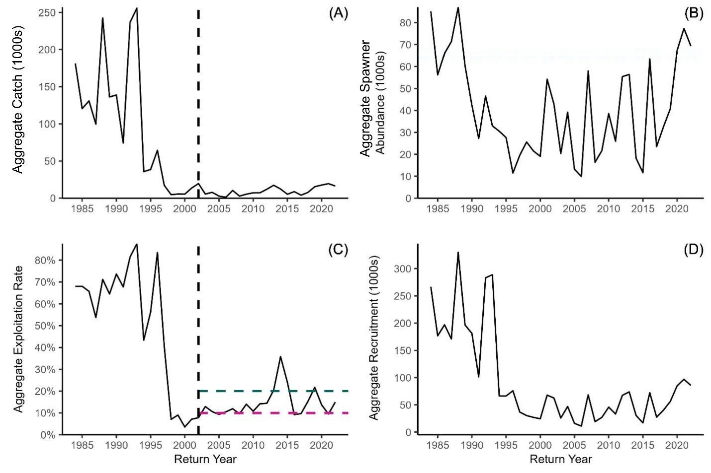

**Figure 2.** Interior Fraser Coho (A) aggregate natural origin catch (1984-2022), (B) aggregate natural origin spawner abundance (1984-2022), (C) aggregate exploitation rate (1984-2022) and the Pacific Salmon Treaty total exploitation rate cap (20%; green dashed line) and domestic exploitation rate cap (10%; pink dashed line), and (D) aggregate natural pre-fishery abundance (1984-2022). Chapter 5 of the PST was finalized in 2002, establishing a management regime for IFC (black dashed line; (A), (B)). CU-specific versions of this plot can be found in Appendix 3 (Figures A1.1 – 1.5).

### Historical and Recent Stock Trajectory and Trends

**Productivity**: Two regimes are apparent in IFC SAS (i.e., marine productivity) through time. The 1984 to 1990 brood years were characterized by a period of relatively high SAS, averaging 6.3% over this time and reaching a maximum of 7.8% in 1987. However, SAS began to decrease in 1991, plummeting to 0.8% in 1992 and then to 0.01% in 2003. SAS has increased gradually since then, averaging 1.5% over the last 10 years (2010-2019) but remains low relative to historic averages (Figure 3). CU-specific trajectories can be found in Appendix 2.

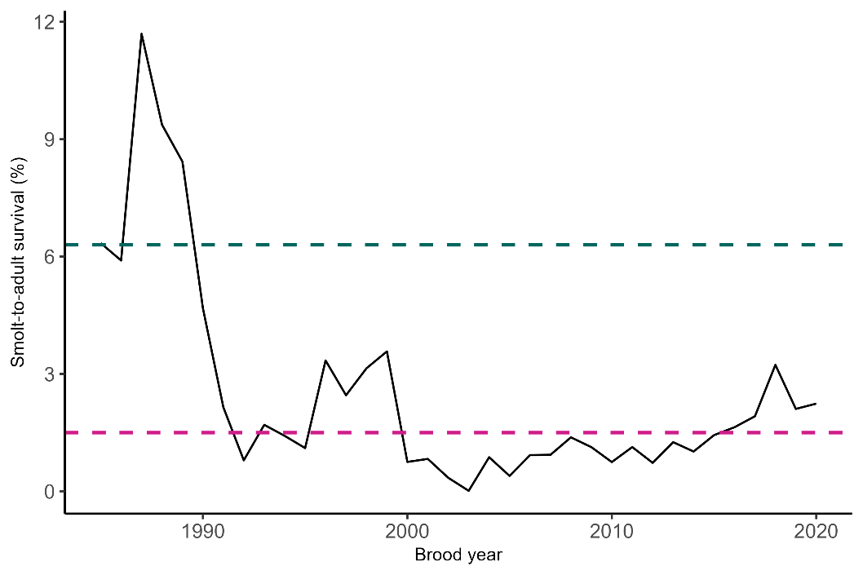

**Figure 3.** Interior Fraser Coho smolt-to-adult survival (1985-2022). Average smolt-to-adult survival in the historic, high productivity regime (6.3%; 1985-1990; pink dashed line). Average smolt-to-adult survival in the last 10 years (1.5%; 2010-2019; green dashed line). The timeseries begins in 1985 because that was the first year that ER was no longer an arithmetic mean (see ER data description above).

Natural IFC pre-fishery and spawner abundance was high during the period of high productivity from return years 1987 to 1993. In 1994, natural pre-fishery and spawner abundance declined rapidly. In the last 10 years (2013-2022), pre-fishery and spawner abundances have increased gradually, but have not recovered to historic abundances (Table 7; Figure 2B,D).

**Table 7.** Interior Fraser coho summarized abundances through time. Note the sharp decline in abundance between 1993 and 1994.

|  |  |  |  |
| --- | --- | --- | --- |
| **Lifestage** | **Years** | **Mean abundance** | **Range** |
| Pre-fishery adults | 1987-1993 | 198,185 | 84,390-302,120 |
| Spawners | 1987-1993 | 52,539 | 27,219-87,021 |
| Pre-fishery adults | 1994-2012 | 38,695 | 11,075-69,521 |
| Spawners | 1994-2012 | 29,000 | 9,912-58,006 |
| Pre-fishery adults | 2013-2022 | 54,598 | 15,337-85,456 |
| Spawners | 2013-2022 | 46,048 | 11,656-77,338 |



The results of population simulation analysis suggest that under current ER and SAS, the probability of the IFC aggregate exceeding the FRP-Ls of 33,500 and 65,300 spawners by 2032 is 90% + and 0-10%, respectively (Figures 4-5). The probability of producing a positive population trajectory under current ER and SAS by 2032 was 0-10% (Figure 6), however, current IFC abundances are relatively high compared to the last 2 decades, thus a positive growth trajectory is unlikely if the current SAS and population productivity remain stable.

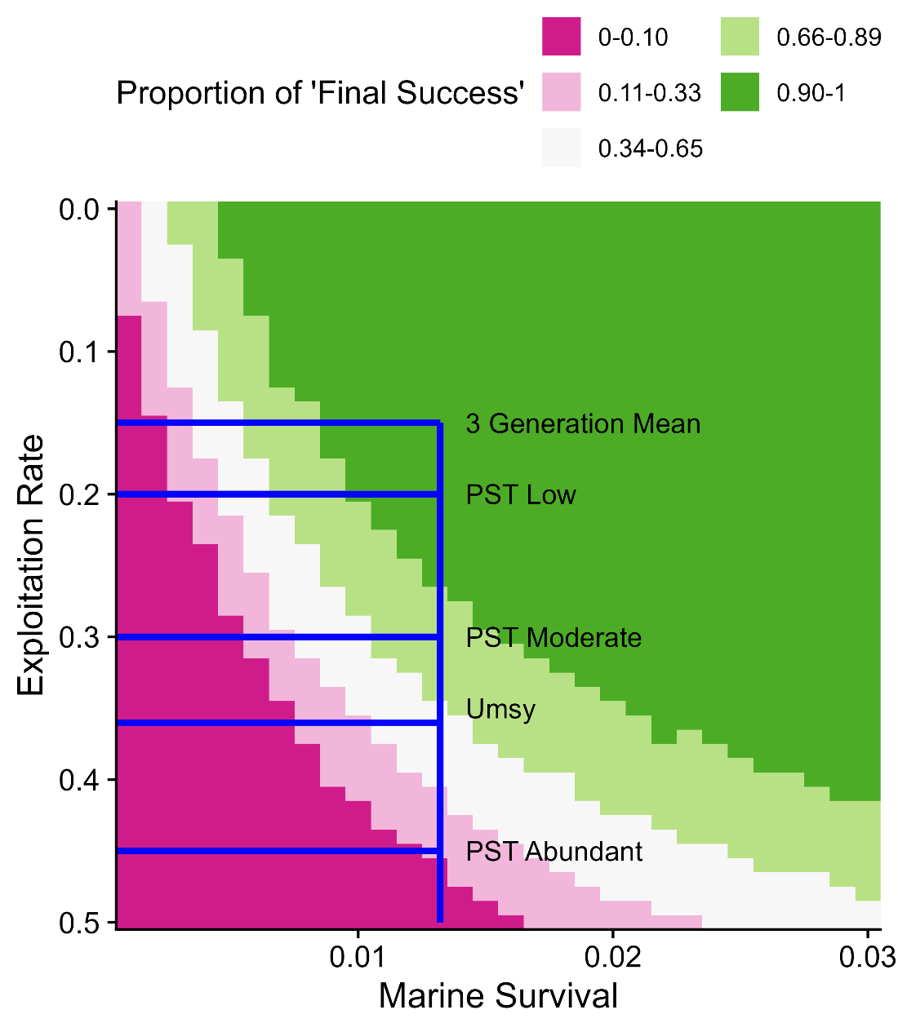

Figure 4. Proportion of simulation results where the final 3-year geometric mean was ≥ 33,500 wild spawners (‘Final Success’). The blue lines intersect at the most recent 3-generation geometric mean smolt-to-adult survival (0.013; vertical blue line) and exploitation rates showing the current 3-generation average, Pacific Salmon Treaty (PST) rates based on IFC abundance, and Umsy as calculated from stock recruit models (see Table 3).

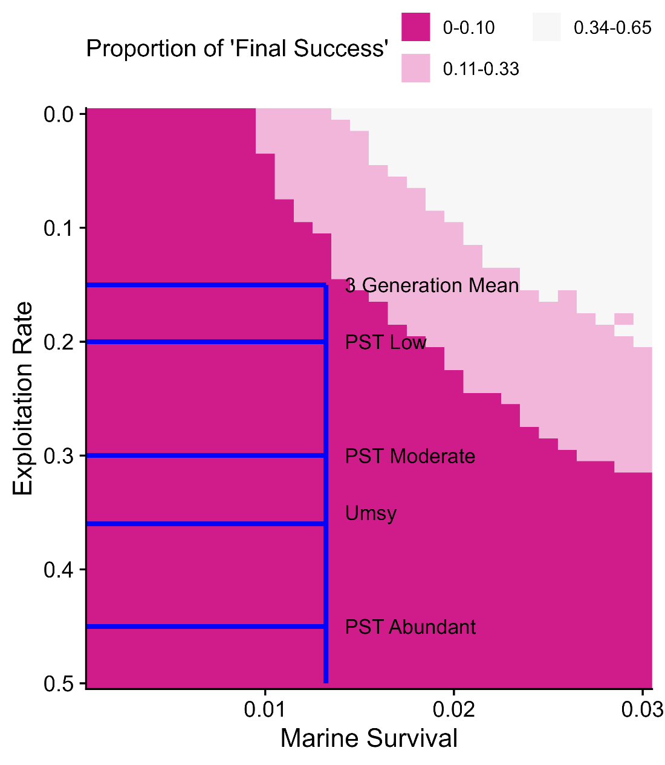

Figure 5. Proportion of simulation results where the final 3-year geometric mean was ≥ 65,300 wild spawners (‘Final Success’). The blue lines intersect at the most recent 3-generation geometric mean smolt-to-adult survival (0.013; vertical blue line) and exploitation rates showing the current 3-generation average, Pacific Salmon Treaty (PST) rates based on IFC abundance, and Umsy as calculated from stock recruit models (see Table 3).

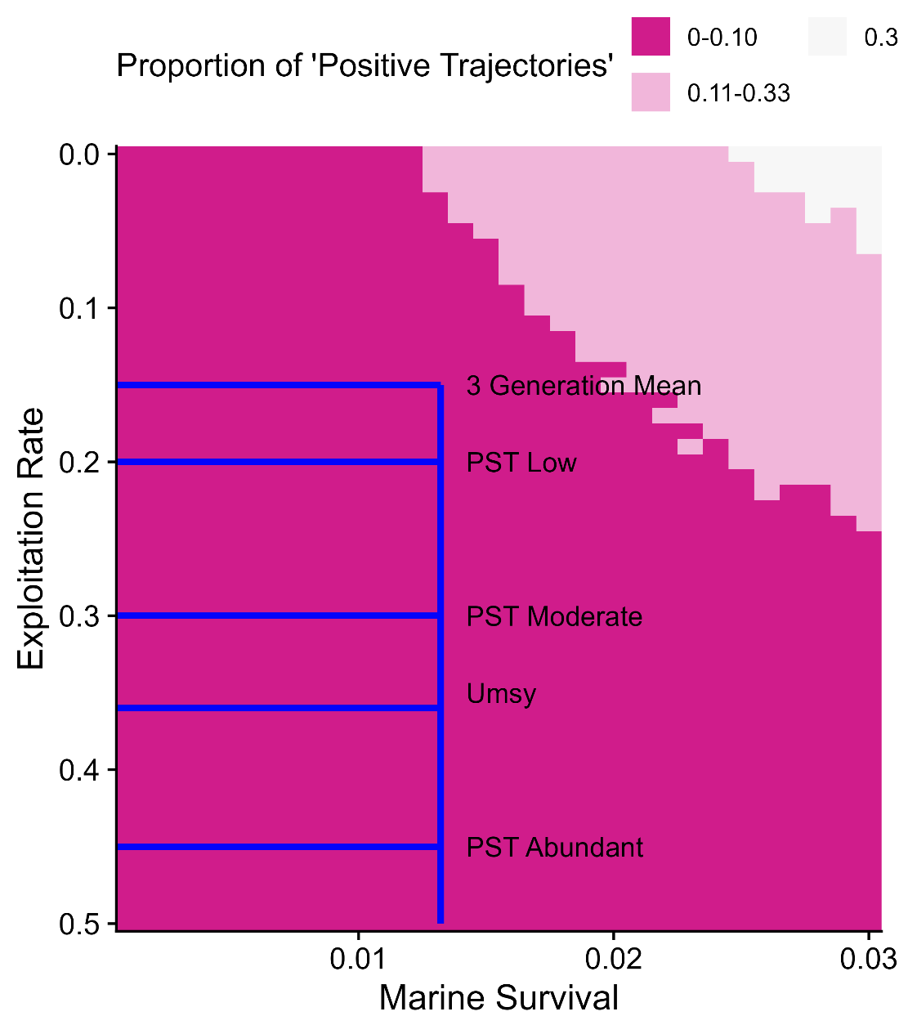

Figure 6. Proportion of simulation results where the population trajectory was positive (‘Positive Trajectory’). The blue lines intersect at the most recent 3-generation geometric mean smolt-to-adult survival (0.013; vertical blue line) and exploitation rates showing the current 3-generation average, Pacific Salmon Treaty (PST) rates based on IFC abundance, and Umsy as calculated from stock recruit models (see Table 3). Note that simulated abundances at the beginning of simulations are relatively high due to recently high IFC abundances, and thus negative population trajectories are likely.

### **History of Harvest**

Historic IFC ERs in Canada were high, averaging 66% between 1984 and 1997. However, declines in IFC productivity, followed by declines in natural pre-fishery and spawner abundance in the mid-1990s resulted in the initiation of a recovery program in 1998 with measures to reduce ER to less than 13% (Decker et al. 2014). Since 1998, ER in Canada has averaged 12.5% (return year 1998-2023; Figure 2C). The ER spike that occurred in 2014 was a result of a 1-time DFO policy allowing up to 16% ER on IFC to create flexibility for harvesting late South Thompson sockeye on a dominant return year (DFO 2024b). However, the ER target was exceeded by a factor of 2, resulting in 32% ER in 2014 (Figure 2C).

History of Hatchery and Supplementation

IFC hatchery enhancement has occurred since the early-1980s and peaked in the late-1980s to early-1990s, averaging 1,600,000 total fry and smolt releases between 1987 and 1993. IFC enhancement has decreased steadily since then with total hatchery releases averaging 339,000 juveniles in the last 10 years (2013-2022; see Appendix 3, Figure A3.0). While smolt releases can be accounted for in the stock-recruit relationship (due to marking with fin clips and CWTs), the impact of fry releases on stock-recruit relationships is unknown. Four CUs (i.e., South Thompson, North Thompson, Lower Thompson, and Middle Fraser) contain integrated-wild populations while the Fraser Canyon CU has a single-site wild-only population.

#### **History of Freshwater Habitat Impacts**

Freshwater habitat is important to IFC, as they spend approximately 50% of their life in freshwater. As juveniles, IFC typically spend a year or more rearing in small- and medium-sized tributaries, and off-channel habitats throughout the Fraser River watershed. Adult IFC will spend weeks or even months in freshwater when they return to spawn. In addition to a severe reduction in SAS, the regime shift to low IFC abundance that started in 1990 was also driven in part by anthropogenic alterations to freshwater habitat (Bradford and Irvine 2000).

The conditions and availability of freshwater habitat used by IFC are impacted by a range of threats including decreased stream discharge (i.e., drought), increased water temperatures, altered land use, urbanization, and invasive species, all of which are associated with or worsened by anthropogenic factors. In particular, the expansion of forestry, agriculture, and urban development throughout the Fraser River has resulted in modifications to catchment surfaces, linear development, and forestry and agricultural effluent, and is correlated with altered flow regimes and hydrology, increased water temperatures, reduced habitat complexity, diversity and connectivity, pollution and contamination, and increased sedimentation. However, in occupying a broad range of freshwater habitats over a large geographical area (i.e., the Fraser River watershed), the relative severity of a given threat to IFC freshwater habitats will vary (Table 8; Arbeider et al., 2020). Unfortunately, these habitat alterations have not been systematically monitored, and thus there is little data available for generating quantitative relationships other than what can be assessed through historical satellite imagery.

Ecosystem and Climate Change Considerations

Declines in IFC pre-fishery abundance in the 1990s is attributed to a reduction in SAS resulting from changing ocean conditions, freshwater habitat alterations, and overexploitation (Bradford and Irvine 2000). Although exploitation has decreased substantially, the severity and immediacy of the other threats have not decreased significantly since then, limiting factors currently posing the greatest threat to IFC are 1) urban development and forestry affecting catchment surfaces, 2) varying freshwater conditions, and 3) varying ocean conditions. The effects of these threats are summarized by life stage in Table 8.

**Table 8.** Interior Fraser River Coho required habitat and the effect of the top 3 threats by life stage. Information adapted from Arbeider et al. (2020).

|  |  |  |
| --- | --- | --- |
| Life stage | Required habitat | Top threats |
| Egg/alevin | Stable, submerged, oxygenated gravel with a mix of ground and surface water | Modifications to catchment surfaces increase the likelihood of dewatering or egg/alevin-scouring flood events. Climate change increases freshwater environmental variation, further increasing the probability of de-watering or scour. |
| Fry/parr | Side channels, shaded small streams, and deeper pools | Modifications to catchment surfaces and freshwater variation driven by climate change alters the freshet, affecting the timing and duration of access to off-channel rearing habitat. In addition, climate changes increases variation in stream temperature, increasing the number of metabolically stressful days. |
| Smolt | Large rivers, estuaries, non-natal tributaries | Modifications to catchment surfaces and freshwater variation driven by climate change alters the freshet, changing the timing of smolt migration and ocean entry. Additionally, marine variation driven by climate change can increase or decrease early marine survival through competition and predation. |
| Immature adult | Coastal waters | Marine variation driven by climate change can increase or decrease growth rates and survival through competition and predation. |
| Spawning adult | Deep pools and stable, submerged, oxygenated gravel with a mix of ground and surface water | Modifications to catchment surfaces and freshwater variation driven by climate change alters surface and groundwater availability, determining whether fish can access preferred spawning areas. |

## BYCATCH

Small numbers of coho Salmon are caught as bycatch in the groundfish trawl fishery in British Columbia, however the stock composition of this bycatch has yet to be examined (Table A4.0 in Appendix 4). Because groundfish trawl fisheries are not fisheries considered in the PST, they are not factored into estimates of ER nor SAS.



## SOURCES OF UNCERTAINTY

Several sources of uncertainty exist in the IFC data, including:

1. Escapement (i.e., spawner abundance) data contains unrepresented observational and statistical error due to variations in spawner assessment methodology (Figure 7) and effort (i.e., quality) (Figure 8), environmental conditions, as well as the as number of systems assessed and the extent of coverage, through time. Changes in assessment methodology were not accounted for in the stock-recruit relationships presented in this document.
2. Generation time and age-at-maturity data are based on ageing scales from senesced adults. Approximately 100 scale samples/CU/year are taken, resulting in small sample sizes and limited spatial representation.
3. ERs have been estimated by the Fisheries Regulation Assessment Model (FRAM) since 2001, which has many assumptions and potential sources of uncertainty, as described by the Model Evaluation Workgroup (Andy Rankis et al. 2008).
4. The measurement scale at the population, CU or SMU-level can be an influential source of uncertainty when inferences are made at a scale that is different from the measurement scale.

Sources of uncertainty are described in further detail by Arbeider et al. (2020).

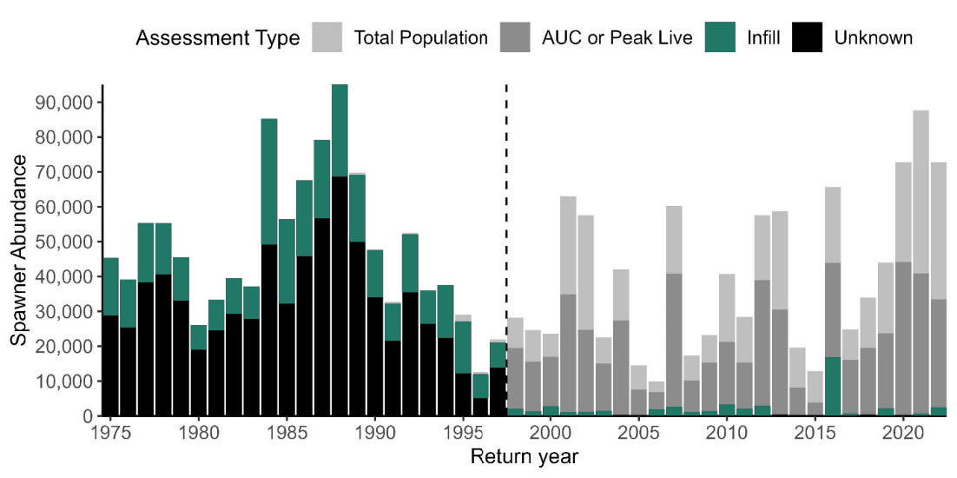

**Figure 7**. Interior Fraser Coho aggregate natural spawner abundance (1975-2022) by assessment type (lightest grey-Total Population, medium light grey-AUC or Peak Live, teal-Infill, black-Unknown). Data quality increases as the shade of grey becomes lighter.

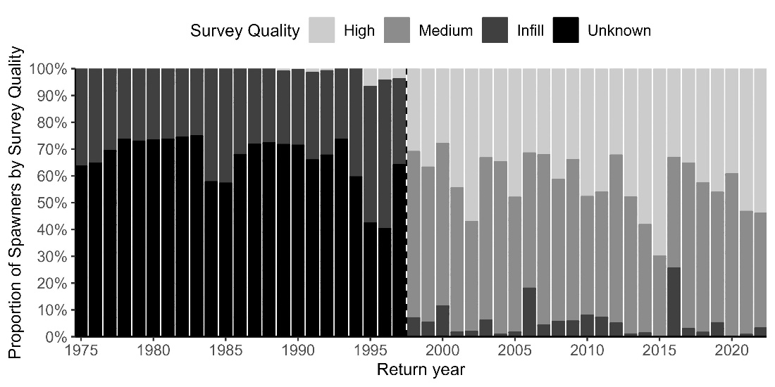

**Figure 8**. Proportion of Interior Fraser Coho natural spawners by survey quality (1975-2022). High survey quality = absolute abundance. Medium survey quality = relative abundance. Infill = abundance was infilled during data preparation steps. Unknown survey qualities occur prior to 1998 and Irvine et al. (1998) describe the quality of these data in detail. Data quality increases as the shade of grey becomes lighter.

## RECOMMENDED RESEARCH

Future work and research on IFC was compiled by the Interior Fraser Coho recovery team (IFCRT 2006). The status of these projects was updated in 2020 by Arbeider et al., and is further updated below in Table 9.

**Table 9.** Studies suggested by the Interior Fraser Coho Recovery Team to identify important habitat for IFC. The study columns and duration are from Table 5 of IFCRT (2006). The status column was added by the authors of the 2020 IFC Recovery Potential Assessment (Arbeider et al. 2020).

|  |  |  |
| --- | --- | --- |
| **Study** | **Duration** | **Status** |
| Map spawning and rearing habitat in the areas used by the Fraser Canyon Coho Salmon population; determine proportions that are within the Nahatlatch River. (Applicable to all CUs). | 2 years | To be done |
| Quantify the relationships between river discharge, velocity, and depth and Coho Salmon passage success at Hells and Little Hells gates. | 2 years | To be done |
| For each Coho Salmon life history stage, characterized the habitat features that support essential life history attributes of IFC | 2 years | Partially complete (Warren 2009) |
| Determine the amount and configuration of habitat features including stream flow requirements, required to support each IFC DU and sub- population at or above the recovery objectives. | 3 years | To be done |
| Determine the amount and configuration of habitat features currently available for each IFC DU and sub-population | 4 years | To be done |
| Map the habitat required to meet population recovery objectives. | 5 years | To be done |
| Compare the habitat available with the habitat required for each IFC sub-population with the objective of determining the need for additional important habitat. | 5 years | To be done |
| Develop an age-structured model and carry out population viability analyses to evaluate relationships among combinations of habitat, marine survival and fishery exploitation rates to estimate probabilities of population extinction, decline, survival, or recovery | 5 years | To be done |
| Map ephemeral streams and assess the importance of ephemeral areas to Coho Salmon rearing and over-wintering behaviour | 4 years | To be done |
| Assess the importance of groundwater levels during winter low water and summer drought periods. | 4 years | Partially complete (McRae et al. 2012) |

## LIST OF MEETING PARTICIPANTS

[Mandatory. The list is to include the name of each participant and their affiliation.]

## SOURCES OF INFORMATION

Andy Rankis, M., Ethan Clemmons, M., Robert Conrad, M., Allen Grover, M., Jim Packer, M., Rishi Sharma, M., Dell Simmons, M., Henry Yuen, M., Chuck Tracy Renee Dorval Ms Carrie Montgomery Ms Kim Merydith, M.M., Hagen-Breaux, A., and Haymes, J. 2008. Fishery regulation assessment model (FRAM) - an overview for coho and chinook -  v3.0. Portland, OR.

Arbeider, M., Ritchie, L., Braun, D., Jenewein, B., Rickards, K., Dionne, K., Holt, C., Labelle, M., Nicklin, P., Mozin, P., Grant, P., Parken, C., and Bailey, R. 2020. Interior Fraser Coho Salmon Recovery Potential Assessment. DFO Can. Sci. Advis. Sec. Res. Doc. **2020/025**(June).

Bailey, C. 2024, October 30. IFC_FSAR_v1.0.

Bradford, M.J., and Irvine, J.R. 2000. Land use, fishing, climate change, and the decline of Thompson River, British Columbia, coho salmon. Canadian Journal of Fisheries and Aquatic Sciences (57): 13–16. Available from www.gdbc.gov.bc.ca.

Carpenter, B., Gelman, A., Hoffman, M.D., Lee, D., Goodrich, B., Betancourt, M., Brubaker, M.A., Guo, J., Li, P., and Riddell, A. 2017. Stan: a probabilistic programming language. J Stat Softw **76**(1): 1–32. doi:10.18637/jss.v076.i01.

Chaput, G., Cass, A.J., Grant, S., Huang, A., and Veinott, G. 2013. Considerations for defining reference points for semelparous species, with emphasis on anadromous salmonid species including iteroparous salmonids. GDFO Can. Sci. Advis. Sec. Res. Doc. **2012**(146): v + 48.

Committee on the Status of Endangered Wildlife in Canada. 2017, October 23. Coho salmon (*Oncorhynchus kisutch*) interior Fraser population: COSEWIC assessment and status report 2016. Available from https://www.canada.ca/en/environment-climate-change/services/species-risk-public-registry/cosewic-assessments-status-reports/coho-salmon-interior-fraser-2016.html [accessed 28 October 2024].

Decker, A.S., Hawkshaw, M.A., Patten, B.A., Sawada, J., Jantz, A.L., Canada, O., Hawkshaw, D.A.S., and Jantz, A.L. 2014. Assessment of the Interior Fraser Coho Salmon (*Oncorhynchus kisutch*) management unit relative to the 2006 conservation strategy recovery objectives. Kamloops, BC. Available from http://www.dfo-mpo.gc.ca/csas-sccs/csas-sccs@dfo-mpo.gc.ca.

Decker, A.S., Irvine, J.R., Canada, O., Decker, A.S., and Irvine, J.R. 2013. Pre-COSEWIC Assessment of Interior Fraser Coho Salmon (Oncorhynchus kisutch). Available from http://www.dfo-mpo.gc.ca/csas-sccs/csas-sccs@dfo-mpo.gc.ca.

DFO. 2015a. Wild Salmon Policy Biological Status Assessment for Conservation Units of Interior Fraser River Coho Salmon (Oncorhynchus Kisutch). DFO Can. Sci. Advis. Sec. Sci. Advis. Rep. **2015**(022): 12.

DFO. 2015b. Development of reference points for Atlantic salmon (Salmo salar) that conform to the Precautionary Approach. DFO Can. Sci. Advis. Sec. Sci. Advis. Rep. **2015/058**(December).

DFO. 2018. SEP production planning: a framework.

DFO. 2022. Methodologies and guidelines for defining limit reference points for Pacific Salmon. CSAS SAR 2022/030. pp. 16. **2022**(July). Available from https://www.dfo-mpo.gc.ca/csas-sccs/Publications/SAR-AS/2022/2022_030-eng.html.

DFO. 2023. Southern salmon integrated fisheries management plan.

DFO. 2024a. Rapid Status Approximations for Pacific Salmon Derived from Integrated Expert Assessments under Fisheries and Oceans Canada Wild Salmon Policy. Nanaimo, BC.

DFO. 2024b, April 9. 2024 management Interior Fraser coho. Fisheries and Oceans Canada, Kamloops. Available from https://frasersalmon.ca/wp-content/uploads/2024/04/2024-Fraser-Coho-Management-2024-04-07-1.pdf [accessed 30 October 2024].

Duplisea, D.E., and Cadigan, N. 2013. Proceedings of the National Workshop for Technical Expertise in Stock Assessment (TESA): Maximum Sustainable Yield (MSY) reference points and the Precautionary Approach when productivity varies. *In* Canadian Science Advisory Secretariat (CSAS) Proceedings Series 2012/055. Montreal. Available from https://waves-vagues.dfo-mpo.gc.ca/Library/348613.pdf.

Fisheries and Oceans Canada. 2005. Canada’s policy for conservation of wild Pacific Salmon. *In* Fisheries and Oceans Canada.

Grant, S., and Pestal, G. 2012. Integrated Biological Status Assessments under the Wild Salmon Policy using standardized metrics and expert judgement: Fraser River Sockeye salmon (*Oncorhynchus nerka*) case studies. Nanaimo, BC.

Hawkshaw, M., and Walters, C. 2015. Harvest control rules for mixed-stock fisheries coping with autocorrelated recruitment variation, conservation of weak stocks, and economic well-being. Canadian Journal of Fisheries and Aquatic Sciences **72**(5): 759–766. National Research Council of Canada. doi:10.1139/cjfas-2014-0212.

Holt, C.A. 2009. Evaluation of benchmarks for conservation units in Canada’s Wild Salmon Policy: technical documentation. Nanaimo, BC.

Holt, C.A., Holt, K.H., Warkentin, L., Wor, C., Connors, B., Grant, S., Huang, A.-M., and Marentette, J. 2023a. Guidelines for defining limit reference points for Pacific salmon stock management units. Canadian Science Advisory Secretariat (CSAS), Nanaimo.

Holt, K., Holt, C.A., Warkentin, L., Wor, C., Davis, B., Arbeider, M., Bokvist, J., Crowley, S., Grant, S.C.H., Luedke, W., McHugh, D., Picco, C., and Will, P. Van. 2023b. Case Study Applications of LRP Estimation Methods to Pacific Salmon Stock Management Units. Can. Sci. Advis. Sec. Res. Doc. **2023/010**(July): iv + 129. Available from https://www.dfo-mpo.gc.ca/csas-sccs/Publications/ResDocs-DocRech/2023/2023_010-eng.html.

Irvine, J.R., Parken, C.K., Chen, D.G., Candy, J., Ming, T., Supernault, J., Shaw, W., and Bailey, R.E. 2001. 2001 stock status assessment of Coho salmon from the Interior Fraser River. Nanaimo, BC.

Korman, J., Sawada, J., and Bradford, M.J. 2019. Evaluation framework for assessing potential Pacific Salmon Commission reference points for population status and associated allowable exploitation rates for Strait of Georgia and Fraser River Coho Salmon Management Units. Vancouver, BC. Available from http://www.dfo-mpo.gc.ca/csas-sccs/.

McRae, C.J., Warren, K.D., and Mark Shrimpton, J. 2012. Spawning site selection in interior Fraser River coho salmon Oncorhynchus kisutch: An imperiled population of anadromous salmon from a snow-dominated watershed. Endanger Species Res **16**(3): 249–260. doi:10.3354/esr00401.

Pacific Salmon Commission. 1985. Pacific Salmon Commission Treaty. Available from http://www.psc.org/.

Pacific Salmon Commission. 2023. Treaty between the Government of Canada and the Government of the United States of America concerning Pacific salmon, as amended through June 2023. *In* Treaty. Canada, USA. Available from https://www.psc.org/about-us/history-purpose/pacific-salmon-treaty/ [accessed 28 October 2024].

Pestal, G., MacDonald, B.L., Grant, S.C.H., and Holt, C.A. 2023. State of the Salmon: rapid status assessment approach for Pacific salmon under Canada’s Wild Salmon Policy. *In* Canadian Technical Report of Fisheries and Aquatic Sciences. Available from https://waves-vagues.dfo-mpo.gc.ca/library-bibliotheque/41207890.pdf.

R Core Team and contributors worldwide. 2017. The R Stats Package.

Simpson, K., Chamberlain, M., Fagan, J., Tanasichuk, R.W., and Dobson, D. 2004. Forecast for southern and central British Columbia Coho salmon in 2004. Nanaimo, BC.

Warren, K.D. 2009, November. Factors influencing habitat use by juvenile Interior Fraser Coho. Masters of Biology, University of Northern British Columbia, Prince George.

Withler, R.E., Bradford, M.J., Willis, D., and Holt, C.A. 2018. Genetically Based Targets for Enhanced Contributions to Canadian Pacific Chinook Salmon Populations. DFO Can. Sci. Advis. Sec. Sci. Advis. Rep. **2018/019**(001): 88 p.

Xuereb, A., Rougemont, Q., Dallaire, X., Moore, J.S., Normandeau, E., Bougas, B., Perreault-Payette, A., Koop, B.F., Withler, R., Beacham, T., and Bernatchez, L. 2022. Re-evaluating Coho salmon (Oncorhynchus kisutch) conservation units in Canada using genomic data. Evol Appl **15**(11): 1925–1944. doi:10.1111/eva.13489.

This Science Advisory Report is from the [meeting date and title (The meeting process, date and title **MUST BE EXACTLY** as they appear for the meeting on the Science Advisory Schedule]. Additional publications from this meeting will be posted on the [Fisheries and Oceans Canada (DFO) Science Advisory Schedule](http://www.isdm-gdsi.gc.ca/csas-sccs/applications/events-evenements/index-eng.asp) as they become available.

## THIS REPORT IS AVAILABLE FROM THE:

Center for Science Advice (CSA) (Shift+Enter)  
Name of Region (Shift+Enter)  
Fisheries and Oceans Canada (Shift+Enter)  
Complete mailing address of CSA Office

Telephone: (Shift+Enter)  
E-Mail: (Shift+Enter)  
Internet address: [www.dfo-mpo.gc.ca/csas-sccs/](http://www.dfo-mpo.gc.ca/csas-sccs/" \o "Fisheries and Oceans Canada / Canadian Science Advisory Secretariat)

ISSN 1919-5087  
© His Majesty the King in Right of Canada, 2022

please recycle

Correct Citation for this Publication:

DFO. 2022. <<insert title here – title must be exactly as it appears on the cover page, but in title case>>. DFO Can. Sci. Advis. Sec. Sci. Advis. Rep. 2022/nnn. (Style: citation)

Aussi disponible en français :

MPO. 2022. << insérez le titre ici – il doit correspondre exactement à celui de la page couverture, mais en lettres minuscules >>. Secr. Can. Des avis sci. Du MPO. Avis sci. 2022/nnn. (Style: citation – other language)

Inuktitut Atuinnaummijuq:

Copy and paste Inuktitut citation here. (Style: citation – other language)

## Appendix 1: Glossary

Benchmarks: also known as “benchmarks of biological status”, these are thresholds used to determine the status (e.g., red, amber, green) of a Conservation Unit (Fisheries and Oceans Canada 2018).

Brood year: the single or main contributing spawning year that produced a group of juveniles or adult recruits (https://www.pac.dfo-mpo.gc.ca/fm-gp/salmon-saumon/gloss-eng.html).

Bycatch: non-target fish species captured in commercial or recreational fisheries (https://www.pac.dfo-mpo.gc.ca/fm-gp/salmon-saumon/gloss-eng.html).

Catchment surface: the land area that rainfall is intercepted by. The qualities of the catchment surface affect how and when water moves through a watershed.

[CU] Conservation Unit: a group of wild Pacific salmon populations that would not recover naturally nor recolonize the habitat after extirpation within a human lifetime (Fisheries and Oceans Canada 2005).

[ER] Exploitation Rate: “expressed as a percentage, the proportion of the total return of adult salmon in a given year that die as a result of fishing activity” (https://www.pac.dfo-mpo.gc.ca/fm-gp/salmon-saumon/gloss-eng.html).

Escapement target: the number of fish fisheries management aspires to return to the spawning grounds.

[FRP-L] Lower Fisheries Reference Point: SMU aggregate abundance reference points (i.e., escapement targets that are relevant to the scale of management and are associated with specific probabilities of the stock exceeding its CU-based LRP.

*Fish Stock Provisions*: an updated section of the *Fisheries Act* that came into force on April 4, 2022 and triggered the development of Fish Science Advice Reports (https://www.dfo-mpo.gc.ca/about-notre-sujet/engagement/2022/fish-stock-provisions-dispositions-stocks-poissons-eng.html).

Full assessment: also known as “full integrated status assessment”, these are the traditional stock status assessments under the Wild Salmon Policy using standardized data reviewed over a multi-day meeting of experts to determine the status of individual Conservation Units (DFO 2015a).

[IFC] Interior Fraser Coho: a genetically and behaviourally distinct stock management unit of coho salmon that spawn in Fraser Watershed upstream of Hell’s Gate (DFO 2015a).

Integrated-wild population: “populations with an integrated hatchery program that is managed to achieve conservation and genetic goals while contributing to production. Benchmarks associated with this category ensure the majority (>50%) of fish spawning in the river meet the criteria for wild under the Wild Salmon Policy and 80% or more of the spawning population will be of natural origin.” (Withler et al. 2018)

[LRP] Limit Reference Point: a scientifically-determined threshold below which Fisheries and Oceans Canada is legally obligated to develop a stock rebuilding plan for a given Stock Management Unit (Holt et al. 2023b).

Natural fish: a fish produced through natural spawning, but whose parents may be of natural or hatchery origin.

Off-channel habitat: Typically small, shallow, often ephemeral (i.e., not always submerged) wetted channels and pools that are seasonally or continuously connected to the mainstem of a stream.

[PA] Precautionary approach: a policy published by Fisheries and Oceans Canada within the Sustainable Fisheries Framework that states the intention of the federal government to use caution when scientific knowledge is uncertain (e.g., harvest less in the face of uncertainty; <https://www.dfo-mpo.gc.ca/reports-rapports/regs/sff-cpd/precautionary-precaution-back-fiche-eng.htm>).

[PNI] Proportionate natural influence: the proportion of natural origin spawners in a salmon population (Withler et al. 2018).

Pre-fishery abundance: The number of estimated adult fish that would have returned to the beginning of their spawning migration in the absence of fishing mortality.

[PST] Pacific Salmon Treaty: An agreement between Canada and the United States to cooperate in the management, research, and enhancement of Pacific Salmon stocks of mutual concern (Pacific Salmon Commission 1985).

Reference points: thresholds that trigger changes in the harvest of stock management units. Limit reference points are scientifically determined, but removal references and upper stock references include both biological and management considerations in their development (Chaput et al. 2013).

Regime shift: a large, rapid change from one relatively stable general pattern to a new pattern.

[RR] Removal Reference: “maximum acceptable removal rate for the stock which would apply when the stock is in the healthy zone and includes all anthropogenic mortality” (DFO 2015b).

[SAS] Smolt-to-Adult Survival: the proportion or percent of smolts that survive to recruit to the fishery. In most cases, smolt counts occur early in the downstream seaward migration, and include downstream freshwater mortality in addition to marine mortality.

[Sgen] The number of spawners required for “recovery to SMSY in one generation under equilibrium conditions” (Duplisea and Cadigan 2013).

[SMSY] Spawners at Maximum Sustainable Yield: the number of spawning adults that generates the greatest difference between the number of spawners and the number of adult recruits they produce (where spawners are fish that escaped the fishery, and recruits are the fish available to the fishery before fishing begins).

[SMU] Stock Management Unit: “a group of one or more conservation units (CU) that are managed together with the objective of achieving a joint status” (https://www.pac.dfo-mpo.gc.ca/pacific-smon-pacifique/science/research-recherche/smon-summ-somm-eng.html). Note that in older documents this is also written as “Management Unit”, or MU.

[TRP] Target Reference Points: specific numerical management objectives that managers attempt to reach that are biologically and socio-economically beneficial (https://www.dfo-mpo.gc.ca/reports-rapports/regs/sff-cpd/precaution-back-fiche-eng.htm).

[UMSY] Fishing mortality rate that will lead to the Maximum Sustainable Yield: the highest sustainable fishing mortality, which would lead spawner abundance to match Spawners at Maximum Sustainable Yield (SMSY).

[USR] Upper Stock Reference: the stock level below which losses must be progressively reduced in order to avoid reaching the LRP. In other words, the point below which harvest control rules change as the population size declines until it reaches the LRP (https://www.dfo-mpo.gc.ca/reports-rapports/regs/sff-cpd/precaution-eng.htm).

Wild population: population of salmon that spent their entire life cycle in the wild and originate from parents that were also produced by natural spawning and continuously lived in the wild (Fisheries and Oceans Canada 2005).

[WSP] Wild Salmon Policy: a policy published by Fisheries and Oceans Canada that states the intention to “restore and maintain healthy and diverse salmon populations and their habitats for the benefit and enjoyment of the people of Canada in perpetuity” and provides guidelines for achieving this objective (Fisheries and Oceans Canada 2005).

WSP Integrated Status: The biological status (green/amber/red) of a conservation unit assessed by a group of experts over a multi-day meeting using standardized data (Pestal et al. 2023).

WSP Salmon Scanner: A tool that approximates the Integrated Status Assessment using the same data inputs and a computer algorithm to estimate the biological status of a conservation unit (Pestal et al. 2023).

## Appendix 2: Wild Salmon Policy Rapid Status

The Wild Salmon Policy Rapid Status assessment assigns a ‘Red’ (poor), ‘Amber’ (intermediate), or ‘Green’ (good) status with ‘Low’, ‘Medium’, or ‘High’ confidence rating to WSP conservation units (CU) with applicable data. CU statuses are generated by applying Pacific salmon CU data to a computer-coded WSP rapid status algorithm that assigns status depending on answers to twelve Yes/No questions that approximate the decision-making process that experts used in WSP integrated status assessments. The combination of metrics applied, and their individual status values compared to metric thresholds, leads to a final WSP rapid status. Metric Dashboards (figures) are also produced for WSP rapid status assessment processes. However, it should be noted that the algorithm thresholds are not always one-to-one with metric benchmarks because the algorithm uses decision rules to approximate expert-driven decisions. Methods and background information are described in greater detail in DFO (2024a).

In an unpublished review (Arbeider M. pers. comm), all First Nation participants stressed the importance of distribution that was metric lacking in the rapid status algorithm. CU-level averages and metrics have the potential to mask underlying stream level risks and observations. The main recommendation was to develop a distribution metric that could be explicitly included in the rapid-status algorithm. Distribution data and targets should also be included in the next Integrated Status Assessment. The lack of distribution metrics has been acknowledged previously in the rapid-status algorithm working group. All First Nation participants identified that the Sgen and 80% SMSY benchmarks did not appear to be adequate or representative of local knowledge. Streams did not appear to be “seeded” to levels from known history. Similarly, these benchmarks do not include distribution information and misalign with other values of Indigenous groups. A common comment was that the values looked too low or that they have been estimated using only data from a low-productivity period. The future work suggested was to investigate alternative benchmarks or methods in developing the benchmarks.

**Figure A2.0.** Interior Fraser Coho WSP rapid statuses for years with applicable data.Each row summarizes the rapid statuses available for each CU in this SMU (Middle Fraser = ‘MFr’, Fraser Canyon = ‘FrCny’, Lower Thompson = ‘Lthom’, North Thompson = ‘Nth’, South Thompson = ‘STh’).

**Table A2.0.** Wild Salmon Policy (WSP) rapid statuses for 2022**:** The WSP rapid status algorithm was used to assess annual statuses for each Interior Fraser Coho CUs.

|  |  |  |  |
| --- | --- | --- | --- |
| **CU #** | **CU Name** | **WSP Rapid Status (2022)** | **WSP rapid status node** |
| **CO-5** | **Fraser Canyon** | **AMBER, MEDIUM CONFIDENCE** | The recent year’s status (2022) is designated *Amber* with *Medium* confidence based on the algorithm. The recent generational average falls between *absolute abundance* lower (1,500) and upper (10,000) thresholds, and also falls above the r*elative-abundance* metric lower benchmark (Sgen) (node 22) (Figure A2.1). This status has been consistent throughout the time series (2000-2022), with the exception of three years that were *Red* (2015-2017) (Figure A2.1). The 2013 WSP rapid status of *Amber* matches the WSP integrated status (DFO 2015a).  Stock assessment moved from a float-based AUC to flight given road access lost after 2020; precision of estimate has gone down. Since it is a single stream CU, there is a risk that one landslide could block passage into spawning grounds. There have been substantial fires in the area that have increased slide risk and impacted the watershed. It is important to track incidences related to landslides and blockages. No First Nation subject matter experts were successfully engaged for this CU. |
| **CO-7** | **Lower Thompson** | **GREEN,**  **HIGH CONFIDENCE** | The recent year’s status (2022) is designated *Green* with *High* confidence based on the algorithm. The recent generational average falls above the *absolute abundance* upper threshold (10,000), and also fall above 1.1 (the *relative-abundance* upper benchmark (80% Smsy) (Node 36) (Figure A2.2). This *Green* status has been consistent for the past three years (2020-2022) (Figure A2.2). Status was *Red* in 2000, the first year in the time series, and in 2005 & 2006. Status was *Amber* for all other years up to 2019. The 2013 WSP rapid status of *Amber* is consistent with the WSP integrated status of *Amber/Green* (DFO 2015a).  One reviewer recommended that the status should be Amber due to the variable time series and recent impacts to the landscape. There is potential capacity and productivity issues from the severe degradation of rearing and spawning habitats due to fires, floods, and drought which are not reflected in the benchmarks of this assessment. Access to the Bonaparte River through it’s fishway was blocked in 2018, resulting in few to no spawners there in 2018 and the primary return year of 2021. It is expected that this impact will persist in 2024. The Coldwater River also experienced extreme flood conditions (>1/100-year-event impact) in Nov 2021, which has potential to cause a recruitment failure in 2024 due to redds being scoured, increased pre-spawn mortality, and other persistent impacts to spawning and rearing areas. |
| **CO-8** | **South Thompson** | **GREEN,**  **HIGH CONFIDENCE** | The recent year’s status (2022) is designated *Green* with *High* confidence based on the algorithm. The recent generational average falls above the *absolute abundance* metric upper threshold (10,000), and also falls above 1.1 (the *relative-abundance* upper benchmark (80% Smsy) (Node 36)(Figure A2.3). This status has been *Green* for the past two years (2021-2022). The status was *Amber* from 2000 to 2020 (Figure A2.3). The 2013 WSP rapid status of *Amber* matches the WSP integrated status (DFO 2015a).  One reviewer recommended that the status should be Amber due the highly variable time series and that the most recent data point is just greater than 10,000. There is potential capacity and productivity issues from the severe degradation of rearing and spawning habitats due to fires, floods, and drought which are not reflected in the benchmarks of this assessment. Salmon River and Bessette River complex are two systems that suffered extreme drought conditions in 2023 and have been experiencing impacts from variable drought conditions in recent years. Widespread fires in the Adams and Little river and Shuswap Lake watersheds will also have persistent impacts to habitat quality and productivity. |
| **CO-9** | **North Thompson** | **GREEN,**  **HIGH CONFIDENCE** | The recent year’s status (2022) is designated *Green* with *High* confidence based on the algorithm. The recent generational average falls above the *absolute abundance* metric algorithm upper threshold (10,000), and also falls above 1.1 (the *relative-abundance* upper benchmark (80% Smsy) (Node 36) (Figure A2.4). The status has been *Green* since 2018. WSP rapid status has alternated between *Green* and *Amber* throughout the time series (2000-2022) (Figure A2.4). The 2013 WSP rapid status of *Green* is consistent with the WSP integrated status of *Amber/Green* (DFO 2015a).  One reviewer was hesitant to agree that the status should be Green due similar recent impacts to spawning and rearing habitat from fires, floods, and droughts that the other Thompson CUs have experienced. Stream access was particularly impacted in 2023 on several North Thompson tributaries due to drought that triggered remediation action (joint activities between Secwepemc Fisheries Commission and DFO). This CU was exemplary that the COSEWIC and WSP benchmarks did not align with local knowledge of Secwepemc as the abundances were still too low and not all spawning areas were as fully seeded as in Secwepemc memory. |
| **CO-48** | **Middle Fraser (‘Interior Fraser’ in NuSeds)** | **GREEN,**  **HIGH CONFIDENCE** | The recent year’s status (2022) is designated *Green* with *High* confidence based on the algorithm. The recent generational average falls above the *absolute abundance* algorithm upper threshold (10,000), and also falls above 1.1 (the *relative-abundance* metric upper benchmark (80% Smsy) (node 36) (Figure A2.5). This status has improved over all previous years, which were *Amber* (2000-2021). WSP rapid status could be assigned for all years starting 2000 (Figure A2.5). The 2013 WSP rapid status of *Amber* matches the integrated status (DFO 2015a). |

### Fraser Canyon Conservation Unit (CO-5)

In 2022, the Fraser Canyon CU status was estimated as ‘Amber’ with medium-confidence by the Rapid Salmon Scanner (Figure A2.0, A2.1; Table A2.0). The recent generational average falls above the *absolute abundance* lower (1,500) threshold (node 1) but below the *absolute abundance* upper (10,000) threshold (node 2). Following algorithm Pathway 2, there is a *relative abundance* metric for this CU (node 5) and the recent generational average falls above the lower benchmark (Sgen) (node 11). Status for this CU is therefore designated as Amber with Medium confidence at Node 22.

During an unpublished expert review (Arbeider pers. comm), it was recorded: There were no dissenting experts on the status of Fraser Canyon as ‘Green’; however, it was noted that no First Nation reviewer’s present could claim to be subject matter experts in this CU. The other major concerns were that this is a single site CU in a canyon with a risk of landslides blocking access and that a 2021 landslide has blocked road access and changed the assessment method.

**Figure A2.1: Metrics and Status for Fraser Canyon Coho (CO-5).** Panels on top show the four standard WSP metrics, calculated based on the available time series of spawner abundances. Bottom panel summarizes the status for each individual metric and shows the resulting rapid status for the CU with a confidence rating. If integrated WSP status assessments have been completed for this CU, they are shown on the last row (IntStatus). In the last integrated assessment, the Fraser Canyon CU was assigned a status of ‘Amber’.

### Lower Thompson Conservation Unit (CO-7)

In 2022, the Lower Thompson CU status was estimated as ‘Green’ with high-confidence by the Rapid Salmon Scanner (Figure A2.0, A2.2; Table A2.0). The recent generational average falls above the *absolute abundance* lower (1,500) threshold (node 1) and above the *absolute abundance* upper (10,000) threshold (node 2). Following algorithm Pathway 1, there is a *relative abundance* metric for this CU (node 4) and the recent generational average falls above the lower benchmark (Sgen) (node 9) and above the upper threshold of 1.1 (the upper benchmark for this metric (80% Smsy). Status for this CU is therefore designated as ‘Green’ with High confidence at Node 36.

During an unpublished expert review (Arbeider pers. comm), it was recorded: There was one dissenting expert on the status of Lower Thompson as ‘Green’ who recommended the status be ‘Amber’. One major concern was that although the last three years rapid-status has been ‘Green’, the overall time series is highly variable. Close monitoring of the percent change and abundance levels are required. Additionally, recent and severe fires and drought conditions are expected to negatively impact the spawning and rearing habitats, which will impact the population’s productivity and abundance trajectory. For example, a failure of the Bonaparte fishway due to a fire impacts in 2018 has resulted in near 0 spawner abundances in that system in both 2018 and 2021 (and expected low returns in 2024).

**Figure A2.2: Metrics and Status for Lower Thompson Coho (CO-7).** Panels on top show the four standard WSP metrics, calculated based on the available time series of spawner abundances. Bottom panel summarizes the status for each individual metric and shows the resulting rapid status for the CU with a confidence rating. If integrated WSP status assessments have been completed for this CU, they are shown on the last row (IntStatus). In the last integrated assessment, the Lower Thompson CU was assigned a status of ‘Amber/Green’.

### South Thompson Conservation Unit (CO-8)

In 2022, the Lower Thompson CU status was estimated as ‘Green’ with high-confidence by the Rapid Salmon Scanner (Figure A2.0, A2.3; Table A2.0). The recent generational average falls above the *absolute abundance* lower (1,500) threshold (node 1) and above the *absolute abundance* upper (10,000) threshold (node 2). Following algorithm Pathway 1, there is a *relative abundance* metric for this CU (node 4) and the recent generational average falls above the lower benchmark (Sgen) (node 9) and above the upper threshold of 1.1 (the upper benchmark for this metric (80% Smsy). Status for this CU is therefore designated as ‘Green’ with High confidence at Node 36.

During an unpublished expert review (Arbeider pers. comm), it was recorded: There was one dissenting expert on the status of South Thompson as ‘Green’ who recommended the status be ‘Amber’. One major concern was that although the last two years rapid-status has been ‘Green’, the overall time series is highly variable. Close monitoring of the percent change and abundance levels are required. Additionally, recent and severe fires and drought conditions are expected to negatively impact the spawning and rearing habitats, which will impact the population’s productivity and abundance trajectory.

**Figure A2.3. Metrics and Status for South Thompson Coho (CO-8).** Panels on top show the four standard WSP metrics, calculated based on the available time series of spawner abundances. Bottom panel summarizes the status for each individual metric and shows the resulting rapid status for the CU with a confidence rating. If integrated WSP status assessments have been completed for this CU, they are shown on the last row (IntStatus). In the last integrated assessment, the South Thompson CU was assigned a status of ‘Amber’.

### North Thompson Conservation Unit (CO-9)

In 2022, the North Thompson CU status was estimated as ‘Green’ with high-confidence by the Rapid Salmon Scanner (Figure A2.0, A2.4; Table A2.0). The recent generational average falls above the *absolute abundance* lower (1,500) threshold (node 1) and above the *absolute abundance* upper (10,000) threshold (node 2). Following algorithm Pathway 1, there is a *relative abundance* metric for this CU (node 4) and the recent generational average falls above the lower benchmark (Sgen) (node 9) and above the upper threshold of 1.1 (the upper benchmark for this metric (80% Smsy). Status for this CU is therefore designated as ‘Green’ with High confidence at Node 36.

During an unpublished expert review (Arbeider pers. comm), it was recorded: There was one uncertain expert on the status of North Thompson as ‘Green’. Recent severe and sustained drought conditions continue to negatively impact spawning and rearing habitat, which will impact the population’s productivity and abundance trajectory.

**Figure A2.4. Metrics and Status for North Thompson Coho (CO-9).** Panels on top show the four standard WSP metrics, calculated based on the available time series of spawner abundances. Bottom panel summarizes the status for each individual metric and shows the resulting rapid status for the CU with a confidence rating. If integrated WSP status assessments have been completed for this CU, they are shown on the last row (IntStatus). In the last integrated assessment, the North Thompson CU was assigned a status of ‘Amber/Green’.

### Middle Fraser Conservation Unit (CO-45)

In 2022, the North Thompson CU status was estimated as ‘Green’ with high-confidence by the Rapid Salmon Scanner (Figure A2.0, A2.5; Table A2.0). The recent generational average falls above the *absolute abundance* lower (1,500) threshold (node 1) and above the *absolute abundance* upper (10,000) threshold (node 2). Following algorithm Pathway 1, there is a *relative abundance* metric for this CU (node 4) and the recent generational average falls above the lower benchmark (Sgen) (node 9) and above the upper threshold of 1.1 (the upper benchmark for this metric (80% Smsy). Status for this CU is therefore designated as ‘Green’ with High confidence at Node 36.

During an unpublished expert review (Arbeider pers. comm), it was recorded: There were no dissenting experts on the status of Middle Fraser as ‘Green’; however, it was stressed that this CU has *just* turned ‘Green’ based on the generational (three-year) geometric mean abundance being greater than 10,000 for the first time in the time series. Close observation of the percent change and relative distribution between the subpopulations and systems was recommended.

**Figure A2.5. Metrics and Status for Middle Fraser Coho (CO-45).** Panels on top show the four standard WSP metrics, calculated based on the available time series of spawner abundances. Bottom panel summarizes the status for each individual metric and shows the resulting rapid status for the CU with a confidence rating. If integrated WSP status assessments have been completed for this CU, they are shown on the last row (IntStatus). In the last integrated assessment, the North Thompson CU was assigned a status of ‘Amber’.

## Appendix 3: Assessment

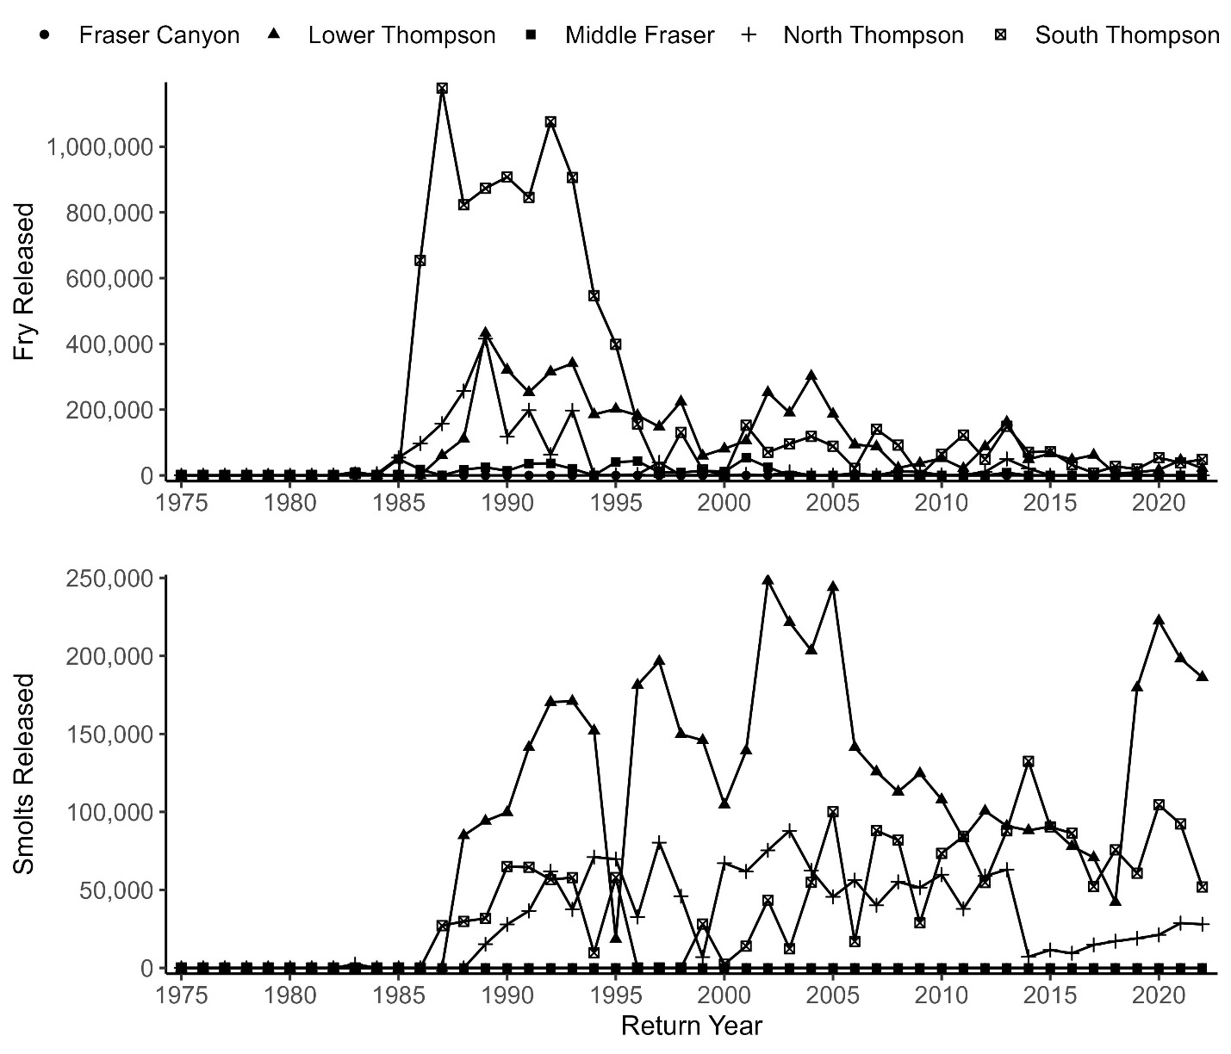

**Figure A3.0.** Interior Fraser Coho smolt and fry releases within each conservation units (Fraser Canyon, Middle Fraser, Lower Thompson, South Thompson, and North Thompson) from 1975-2022.

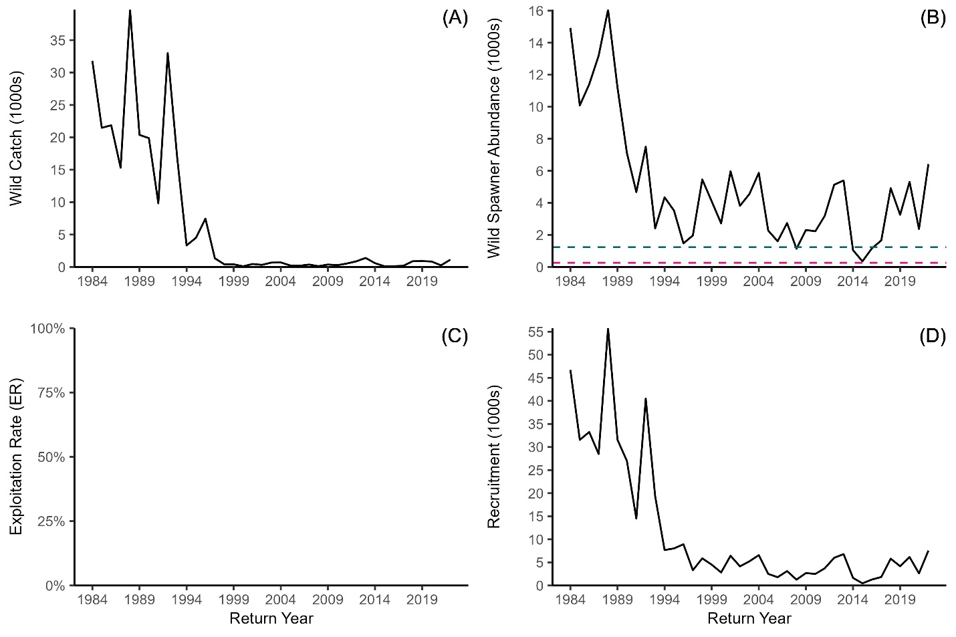**Figure A3.1.** Interior Fraser Coho Fraser Canyon conservation unit (A) natural catch (1984-2022), (B) natural spawner abundance (1984-2022) with 80% SMSY (green dashed line) and Sgen (pink dashed line), and (D) aggregate natural pre-fishery abundance (1984-2022). Note: IFC exploitation rates are not estimated at the conservation unit level.

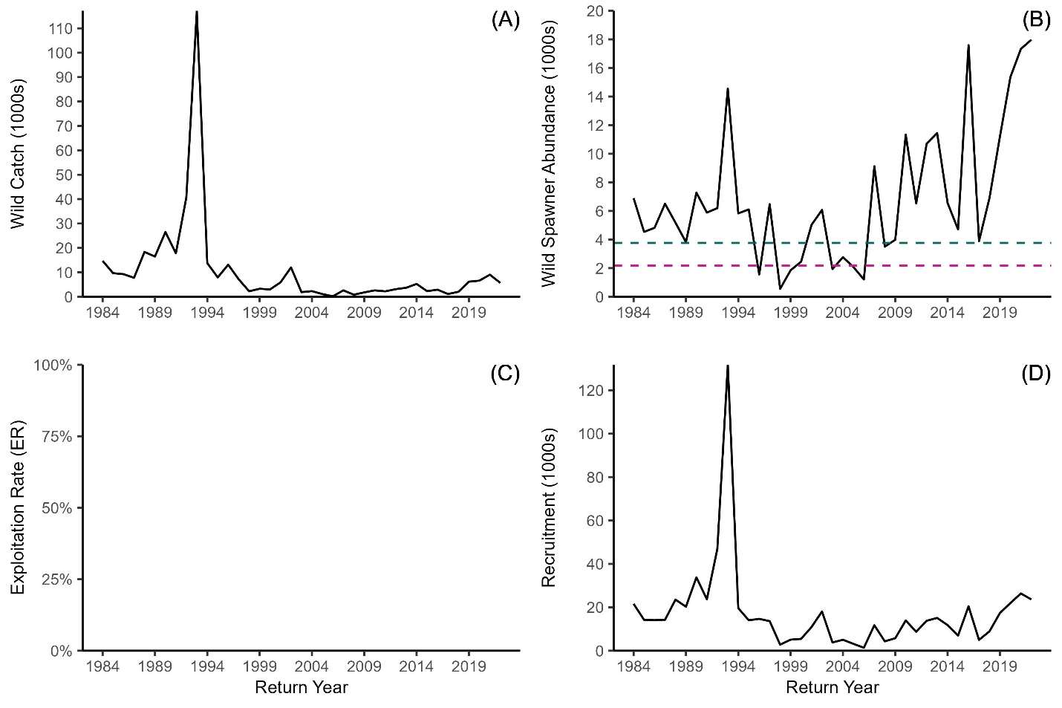**Figure A3.2.** Interior Fraser Coho Lower Thompson conservation unit (A) natural catch (1984-2022), (B) natural spawner abundance (1984-2022) with 80% SMSY (green dashed line) and Sgen (pink dashed line), and (D) aggregate natural pre-fishery abundance (1984-2022). Note: IFC exploitation rates are not estimated at the conservation unit level.

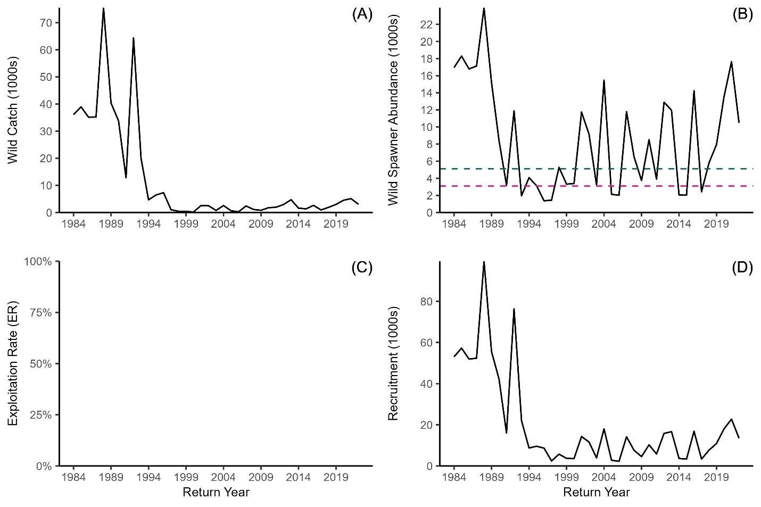**Figure A3.3.** Interior Fraser Coho South Thompson conservation unit (A) natural catch (1984-2022), (B) natural spawner abundance (1984-2022) with 80% SMSY (green dashed line) and Sgen (pink dashed line), and (D) aggregate natural pre-fishery abundance (1984-2022). Note: IFC exploitation rates are not estimated at the conservation unit level.

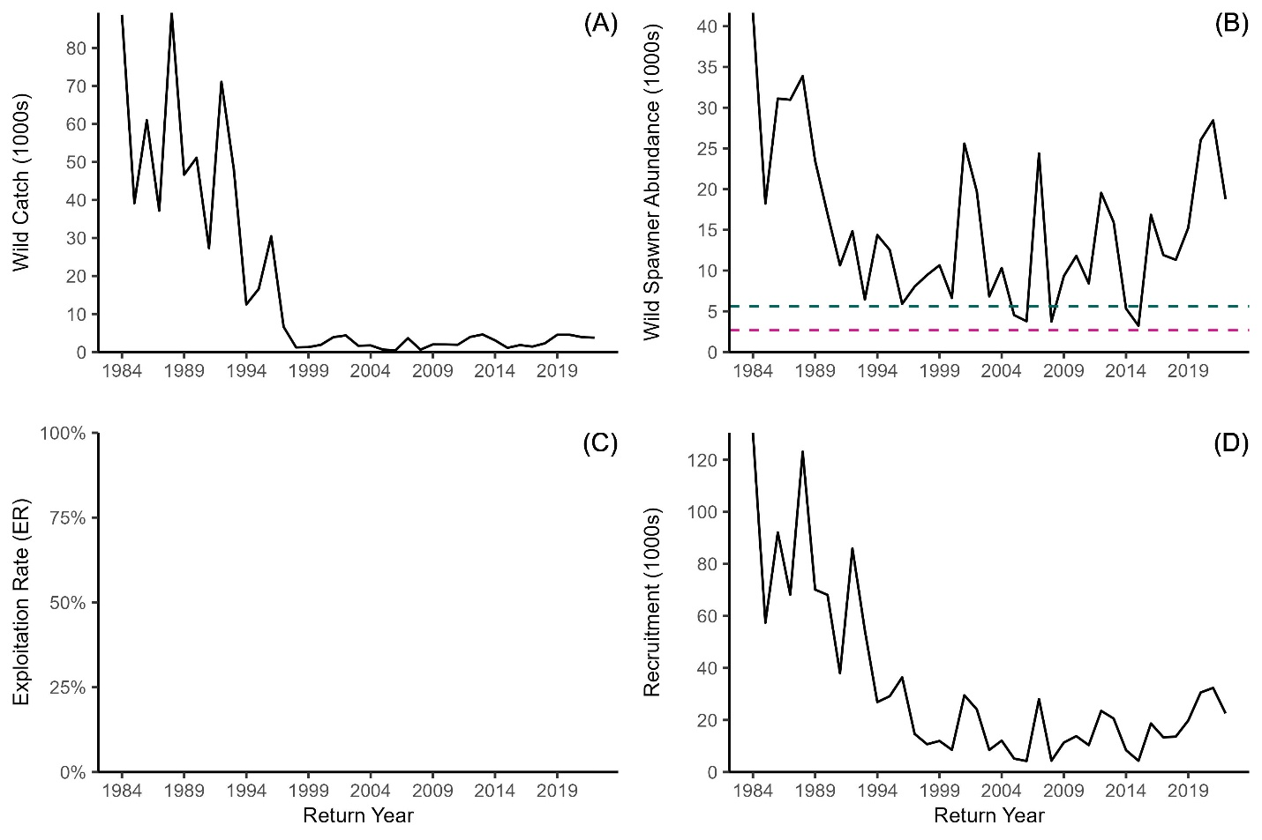**Figure A3.4.** Interior Fraser Coho North Thompson conservation unit (A) natural catch (1984-2022), (B) natural spawner abundance (1984-2022) with 80% SMSY (green dashed line) and Sgen (pink dashed line), and (D) aggregate natural pre-fishery abundance (1984-2022). Note: IFC exploitation rates are not estimated at the conservation unit level.

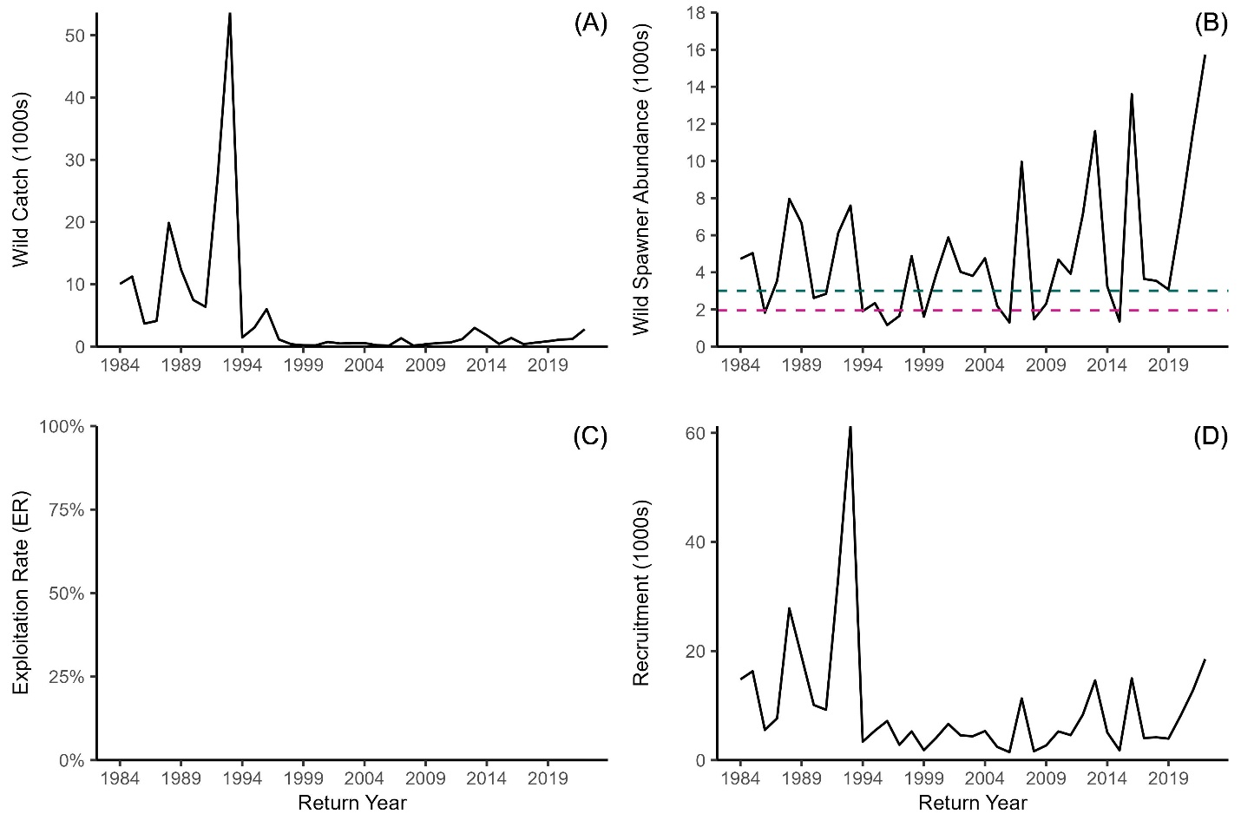**Figure A3.5.** Interior Fraser Coho Middle Fraser conservation unit (A) natural catch (1984-2022), (B) natural spawner abundance (1984-2022) with 80% SMSY (green dashed line) and Sgen (pink dashed line), and (D) aggregate natural pre-fishery abundance (1984-2022). Note: IFC exploitation rates are not estimated at the conservation unit level.







## Appendix 4: Bycatch

**Table A4.0**. Pacific Salmon bycatch within the Pacific Region groundfish trawl fishery in British Columbia.

|  |  |  |  |
| --- | --- | --- | --- |
| **Year** | **Coho catch** | **Total salmon catch abundance** | **Unidentified salmon catch** |
| 2008 | 26 | 3,209 | 102 |
| 2009 | 121 | 9,646 | 83 |
| 2010 | 65 | 7,582 | 151 |
| 2011 | 242 | 11,081 | 282 |
| 2012 | 378 | 8,299 | 217 |
| 2013 | 289 | 4,681 | 567 |
| 2014 | 247 | 7,299 | 360 |
| 2015 | 211 | 8,171 | 234 |
| 2016 | 400 | 3,157 | 200 |
| 2017 | 129 | 6,839 | 240 |
| 2018 | 119 | 9,218 | 196 |
| 2019 | 146 | 7,328 | 294 |
| 2020 | 83 | 10,002 | 254 |
| 2021 | 697 | 14,270 | 0 |
| 2022 | 613 | 24,457 | 122 |